Took a quick look at the Alachua County Library District CAFR and wanted to forward some comparative data.

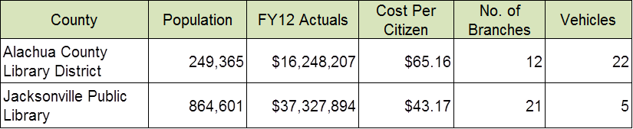

The Library District has an interlocal agreement with Alachua County for some County services including accounting, auditing, treasury, miscellaneous administrative services, information and telecommunications services, and the county attorney.   They also participate in the County’s self-insurance fund for workers compensation and in the County’s self-insured health insurance fund for employee group health insurance.   All employees hired after 1/1/2008 were only allowed to participate FRS pension plan.

Angela Moyer

Budget Office - City of Jacksonville

(904) 630-1301