City of Jacksonville Tuesday, June 17, 2025
12:30 PM
117 W. Duval Street Jacksonville, FL 32202
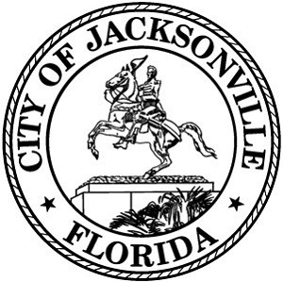
Council Chamber, 1st Floor, City Hall

Special Committee on Duval DOGE

Agenda

June 17, 2025
12:30 PM
City Council Chamber

Call to Order and Introductions

- Financial Services Update

- Building Efficiencies Update

- Summary of Takeaways from Analysis

- Questions and Comments

- Adjourn

Page 1 of 1

