City of Jacksonville Tuesday, May 20, 2025
12:30 PM
117 W. Duval Street Jacksonville, FL 32202
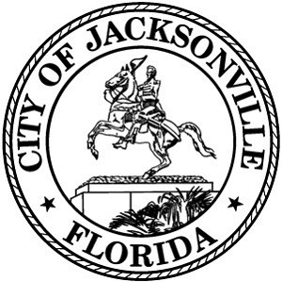
Council Chamber, 1st Floor, City Hall

Special Committee on Duval DOGE

Agenda

May 20, 2025
12:30 PM
City Council Chamber

Call to Order and Introductions

- Administration – Procurement Card Presentation

- CIP – Status Update and Proposed Legislation

- City Facilities – (Libraries, Senior Centers, and Community Centers)

- Questions and Comments

- Adjourn

Page 1 of 1

