City of Jacksonville Tuesday, April 1, 2025
12:30 PM
117 W. Duval Street Jacksonville, FL 32202
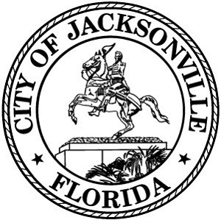
Council Chamber, 1st Floor, City Hall

Special Committee on Duval DOGE

Agenda

April 1, 2025
12:30 PM
City Council Chamber

Call to Order and Introductions

- Preliminary Discussion on Capital Improvement Plan

- Discussion on Growth in Departments

- Questions and Comments

- Adjourn

Page 1 of 1

