City of Jacksonville Tuesday, February 3, 2026
11:00 AM
117 W. Duval Street Jacksonville, FL 32202
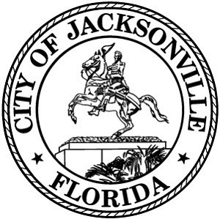
Council Chamber, 1st Floor, City Hall

Special Committee on Duval DOGE

Agenda

February 3, 2026
11:00 AM
City Council Chamber

Call to Order and Introductions

- Public Comment

- Florida DOGE Report on Local Government Spending- January 2026

- Comments from Committee

- Adjourn

Page 1 of 1

