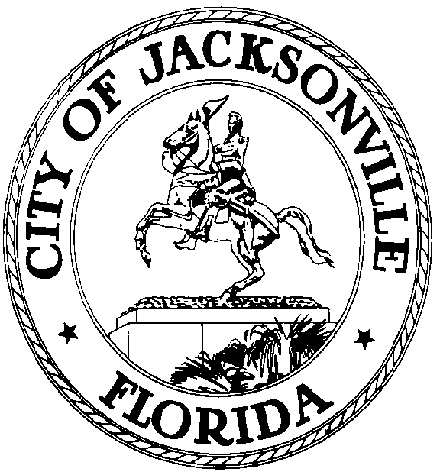

GARRETT L. DENNIS
Council Member District 9
E-Mail: GarrettD@coj.net

OFFICE OF THE CITY COUNCIL
117 West Duval Street City Hall, Suite 425
Jacksonville, Florida 32202
Office (904) 255-5209
Fax (904) 255-5230

MEDIA RELEASE

FOR IMMEDIATE RELEASE – August 4, 2021
Contact: Garrett Dennis (904) 887-1870

COUNCILMAN GARRETT DENNIS INTRODUCES

LEGISLATION TO ADD THREE ADDITIONAL COVID SITES

With the uptick in COVID cases and long waiting lines at current testing sites. Councilman Dennis is proposing the addition of 3 testing sites to be located at Shoppes at Sherwood, Lane Wiley Center, and College Park Center in Arlington. He is asking for emergency funding in the amount of $5 million.

“As a community, we must make testing not only widely available, but also convenient with accessibility to public transportation. Identifying those infected will obviously prevent the continuous spread by requiring immediate quarantine.” Dennis said.

Jacksonville is currently leading Florida with COVID cases.

