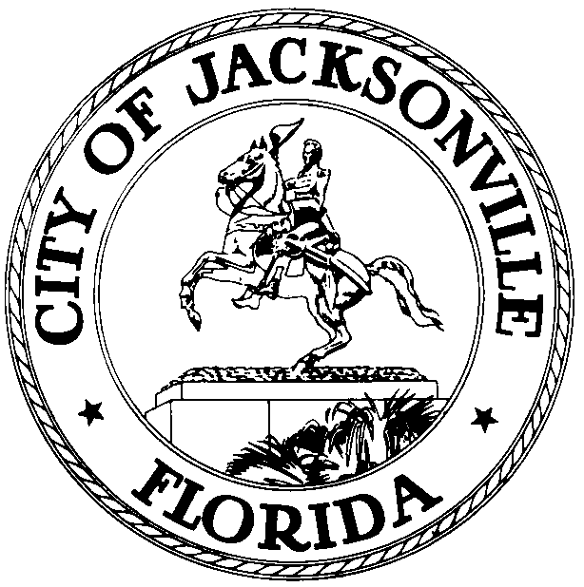

OFFICE OF THE CITY COUNCIL

DANIEL DAVIS 117 WEST DUVAL STREET, SUITE 425
2007 – 2008 PAST PRESIDENT 4TH FLOOR, CITY HALL
OFFICE (904) 630-1380 JACKSONVILLE, FLORIDA 32202
FAX (904) 630-2906
E-MAIL: DDAVIS @COJ..NET

October 7, 2008
(10:10 am)

AMENDED NOTICE

M E M O R A N D U M

TO: Honorable Arthur Graham- Member
Seaport & Airport Special Committee

Honorable Stephen Joost- Member
Seaport & Airport Special Committee

FR: Honorable Daniel Davis, Chairman
Seaport & Airport Special Committee

RE: Seaport and Airport Special Committee Mtg. Dates and Times
_____________________________________________________________

Notice is hereby given that The Honorable Daniel Davis, Chairman of the Seaport and Airport Special Committee for the Jacksonville City Council sets the following meeting dates and times. Chairman Davis will meet with the Special Committee Members on the second and fourth week of each month in the Lynwood Roberts Room, 1st Floor, City Hall at St. James, 117 West Duval Street, Jacksonville, Florida. The Special Committee is noticed as follows:

SPECIAL COMMITTEE GOALS & SCHEDULE:
Seaport and Airport Committee:

The committee will be charged with helping JAXPORT and the JAA find and secure the resources they need to accommodate the city’s growing seaport business and the economic development opportunities at Cecil Field. One critical function of the committee will be to identify potential state and federal funding sources for these improvements. The committee also will act as the liaison with local, state and federal officials to help prioritize infrastructure projects and assist with identifying funding sources that stimulate economic development. The special committee will place particular emphasis on road improvements needed in north Jacksonville to handle increased truck traffic and rail. Additionally, a deeper harbor is necessary to handle the larger vessels calling the port, including those brought by Mitsui and its vessel partners, as well those projected to use JAXPORT after the 2014 widening of the Panama Canal.

Seaport & Airport Special Committee Members:
Daniel Davis - Chair
Arthur Graham- Member
Stephen Joost- Member
Liaisons:
Daniel Davis - Chair Dr. Johnny Gaffney- JPA
Ray Holt- JAA
Seaport & Airport Special Committee Staff:
Legislative Aide – Merrianne Lahmeur (904) 630-1404
Alternate Aide- Marilyn Allen (904) 630-1404
Seaport and Airport Special Committee Meeting Location/Time: Web Calendar
Second & Fourth Week Month. Tuesday
Lynwood Roberts Room
First Floor, City Hall- St. James Bldg.

SEAPORT & AIRPORT SPECIAL COMMITTEE MEETING DATES AND TIMES
Dates Times
8/26/08 3:30 PM
9/9/08 4:00 PM
9/23/08 4:00 PM
10/14/08 4:00 PM
10/28/08 4:00 PM
11/12/08 4:00 PM **Rescheduled to 11/10/08 at 4:00 p.m.
11/25/08 4:00 PM
12/09/08 4:00 PM
01/13/09 4:00 PM
01/27/09 4:00 PM
02/10/09 4:00 PM
02/24/09 4:00 PM
03/10/09 4:00 PM
03/24/09 4:00 PM
04/14/09 4:00 PM
04/28/09 4:00 PM
05/12/09 4:00 PM
05/26/09 4: 00 PM
06/09/09 4:00 PM
06/23/09 4:00 PM

ALL interested parties are invited to attend.
Please contact Merriane Lahmeur - Legislative Services Division at (904) 630-1404 for additional information or correspondence.

/clb

xc: Council Members/Staff
Honorable Dr. Johnny Gaffney- Liaison JPA
Honorable Ray Holt- Liaison - JAA
Cheryl L. Brown, Director/Council Secretary
Merriane Lahmeur- Legislative Assistant II
Dana Farris, Chief – Legislative Services Division
Carol Owens, Assistant Chief – Legislative Services Division
Jeff Clements, Chief, Research Division
Kristi Sikes, Chief, Administrative Services Division
Shannon Hewett, Mayor’s Office
Ron Barton, JEDC
Jessica Deal, Chamber of Commerce Government Affairs
Eric Green, JPA
Rick Ferrin, Executive Director- JPA
John Clark, Executive Director -JAA
Office of the General Counsel
CITYC@COJ.NET
Electronic Notice Kiosk – 1st Floor City Hall
Public Notice System – City Council Web Page
Media Box
File Copy

