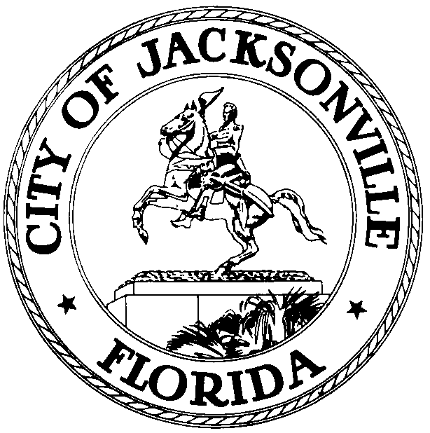

Office of the City Council
Legislative Services Division

Jessica B. Matthews 117. W. Duval Street
Chief of Legislative Services Suite 430
OFFICE (904) 255-5122 Jacksonville, Florida
FAX (904) 255-5132 32202

November 14, 2019
(5:00 p.m.)

Meeting Notice

TO: CRC- City-Wide Strategic Planning Subcommittee Members
-Commissioner William C. Gentry
-Commissioner Emily Liska
-Commissioner Nick Howland
-Commissioner Chris Hagan

FROM: Betsy Santiago, Chair

RE: 20191114 CRC- City-Wide Strategic Planning Subcommittee Meeting Notice Dates

As Chair of the Charter Revision Commission- City-Wide Strategic Planning Subcommittee, I have hereby scheduled the meetings below:
- December 6th, 2019 at 12p.m. until 2 p.m.
- December 16th, 2019 1:30 p.m. until 3:30 p.m.
- January 3rd, 2020 9a.m. until 11 a.m.

The Meeting will be held in the Don Davis Room on the 1st Floor, City Hall, St. James Bldg., 117 West Duval Street, Jacksonville, FL 32202.

Please mark your calendars accordingly. All interested parties are invited to attend. Please contact Jessica Matthews/Crystal Shemwell at (904) 255-5122 for additional information or correspondence.

JBM
E-mail: Council Members/Staff
Cheryl Brown, Director/Council Secretary
Jeff Clements, Chief of Research
Paige Johnston, General Counsel
CITYC@COJ.NET
Posted Notice Board, 1st Fl, City Hall
Public Notice System, City Council Web Page
Media Box

