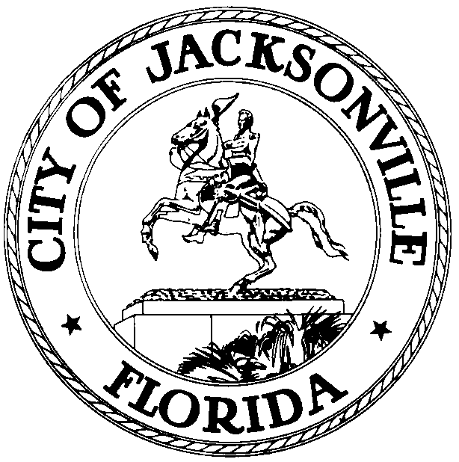

Jacksonville Waterways Commission
Aaron Bowman, Chair

JACKSONVILLE WATERWAYS COMMISSION
Wednesday, April 12, 2017
City Council Chamber
9:30 a.m.

The monthly meeting of the Jacksonville Waterways Commission was called to order on Wednesday, April 12, 2017, at 9:31 A.M., by the Chair, Council Member Aaron Bowman.

In attendance: Council Members Aaron Bowman (Chair), Jim Love (Vice Chair), Anna Lopez Brosche; Council President Lori Boyer; Commissioners Gary Anderson, Garrett Barket, Lane T. Burnett, Jed Davis, Steven Davis, Jill D. Haskell, Ralph C. Hodges, Raymond S. Pringle, Jr., Steve Swann, Marshall Adkison, Ex-Officio, Michelle Tappouni, Ex-Officio; Assistant General Counsel Paige Johnston; Dr. Quinton White, Dr. Gerard Pinto, Jacksonville University; Captain Jim Suber, Waterways Coordinator/City Harbormaster; Jessica Baker, Intergovernmental Affairs; Jessica Matthews, Samantha Lane, Staci Lopez, Legislative Services; John J. Jackson, Council Research Division. (see attached sign-in sheet for additional attendees).

The Commission voted to approve the minutes for the March 15, 2017 meeting, as distributed.

The first item on the agenda was a land use amendment. Ordinance 2017-215, Adopt Small Scale FLUM Amend to 2030 Comp Plan – Prpty on E/S of San Jose Blvd bet Hidden Stagecoach Rd & Sweetholly Dr (1.49± Acres) – RPI to CGC – Savvas Savvidis. Ed Lukacovic, City Planner III, Planning & Development Department, made the presentation. He was accompanied by Mr. Ross Glass, the applicant for the land use amendment. The applicant would like to have a facility that will enable him to sell golf carts and batteries for golf carts.

The site is located on the east side of San Jose Boulevard between Hidden Stagecoach Road and Sweetholly Drive. It is 1.49 acres in size. The current land use category of the site is RPI (Residential, Professional, Industrial). The proposed land use category is CGC (Community, General, Commercial). The current and proposed zoning is PUD. The sub-drainage basin is Cormorant Creek. The drainage basin is Julington Creek onto the St. Johns River. The site is located in Council District 6 and Planning District 3.

Mr. Lukacovic gave a brief history of the site, described the type of soil, showed photographs of the area, and characterized the area is located within a flood zone. He fielded numerous questions on such matters as the retention pond at the site, the impact of the proposed category on wetlands and on whether or not a site plan is required for this land use amendment (it is not). On a vote of 12-0, the Commission voted to approve Ordinance 2017-215.

The Commission next heard a PowerPoint presentation on the City’s artificial reef program by John Flowe, Environmental Engineering Manager, the Environmental Quality Division, Neighborhoods Department.

Mr. Flowe explained how the artificial reef program works. He cited ten steps in the process. First, a permit has to be acquired from the U.S. Army Corps of Engineers. Currently, the City has 21 USACOE offshore permits. Two of those permits expire in July 2019; the other nineteen expire in December 2019. The second step is to get suitable materials for an artificial reef. The various, available sources of suitable materials include: prefabricated reef modules. These reef balls have been put together by Mandarin High School students for a number of years and earned the school a national award. Another source could be clean concrete and debris in the form of culverts and at bridge demolition debris; the I-95 Overland Bridge rubble cited as an example of the latter. Identifying sources for funding is the third step in the program. The Florida Fish and Wildlife Conservation Commission provides some funding for artificial reefs. The Coastal Conservation Association is another source. In 2009, the City Council enacted 2009-442-E that created the Artificial Reef Trust Fund enabling the City to receive donations, grants, contributions and donations to fund the deployment of artificial reefs.

The fourth step in the artificial reef program is choosing a spot for the deployment of an artificial reef. You would not want to deploy near an existing reef. There has to be proper clearance (water depth). Boating traffic is a factor. Shrimpers are adamantly opposed to deploying artificial reefs in areas that draw commercial shrimp boats. Artificial reefs should not be constructed on many types of natural habitats such as significant beds of aquatic grasses, scallop, mussel or clam beds, existing coral reefs and oyster reefs. Pre-deployment paper work is the fifth step in the process and this entails a pre-deployment survey (dive) and notification to the Army Corps of Engineers.

The sixth step in the process is to hire transportation, storage, loading and offshore transportation. This process involves moving the artificial reef material from its source to interim storage or final deployment site. Deploying (sinking) the material is the seventh step. The eighth step is post-deployment paperwork, a placement report to the Florida Fish & Wildlife Conservation Commission. A key component of the process is the ninth step, publicizing the artificial reef so as to attract anglers to a recreational fishing destination. Social media is exceedingly helpful. The websites of such organizations as the Coastal Conservation Association and Tisiri should be utilized. The tenth and final step in the artificial reef program is to actually go fishing. The last photograph in the PowerPoint showed three anglers afloat on the St. Johns River, just south of the Fuller Warren Bridge, where, on March 26, 2017, two years and three months after the deployment of an artificial reef, with about 40 yellowmouth trout that had been caught.

Though a contract had not yet been finalized, Mr. Flowe indicated that Jacksonville University has already begun to monitor the City’s artificial reefs in the St. Johns River.

The Chair, Council Member Bowman, suggested that the City should seek a partnership with the U.S. Navy in sinking ships for artificial reefs. Dr. Quinton White indicated that the Navy has actually been cooperative in doing so in the past.

Janie Thomas, Executive Director of the Shrimp Producers Association, said that artificial reefs should not be deployed within three miles of shrimping operations. If the City is going to deploy additional artificial reefs in the St. Johns River in the future, the City needs to notify the Shrimp Producers Association. Ms. Thomas referenced the Waterways Commission’s subcommittee on artificial reefs meetings held several years ago; a number of the area’s shrimpers attended the subcommittee meetings to explain the problems that they had with the artificial reef program. Ms. Thomas also remarked that the potential dredge project would adversely impact the shrimping industry because of the expected sharp increase of salinity in the river.

Council President Lori Boyer addressed the Waterways Commission on the matter of an ADA access kayak launch at the Duval County School Board property site that the Commission had previously discussed. She indicated that the School Board had approved the project. She explained that as a result of the safety concerns previously raised because of the strong current in the river at this particular site, consideration had to be given to the type of launch to be constructed. A beach launch consisting of gravel would be problematic for wheelchairs. There would be a liability issue if concrete was used. When wet, concrete would be slippery. Commissioner Garrett Barket was particularly concerned with concrete; he envisioned a wheelchair rolling into the river.

Joseph Daryl said that the design for the kayak launch at the School Board property site had not been decided; it is still in the design process. He explained that the Parks, Recreation and Community Services Department wanted to gather the Waterways Commission’s input on the matter.

John Nooney indicated that he favored a hand launch for the site.

The Commission returned to agenda items and heard a presentation by Joe Kistel on raising awareness of Offshore Jacksonville Opportunities. Mr. Kistel is Executive Director of Tisiri (Think It Sink It Reef It).

Mr. Kistel spoke of the many economic benefits of offshore facilities such as artificial reefs.
He had previously cited how other counties had invested in offshore facilities and experienced positive economic impacts.

Mr. Kistel wants to get the City of Jacksonville involved in an awareness campaign to let people know what we have offshore. He said the City would benefit economically if people were aware of the opportunities offshore for scuba diving and salt water fishing. He wants to see a website hypothetical developed as UWJAX (Discover Underwater and Offshore Jacksonville). Mr. Kistel sees the potential in producing videos on diving, fishing, species of interest, reefs and science-focused videos. Mr. Kistel explained that the website and videos would attract that individual in Wisconsin who was scanning websites for diving opportunities.

Mr. Kistel announced that he had a proposal to present to the City of Jacksonville. The Chair, Council Member Bowman, suggested that Mr. Kistel might want to set up a meeting with the Council President and present his proposal and ideas to the Entertainment Subcommittee that Commissioner Gary Anderson chairs.

Next on the agenda was the St. Johns River Status Report on Water Quality and Manatees.
Dr. Quinton White said that as the weather warms up and Summer returns, he is concerned that toxic algae might return because of the level of nutrients in the river. He reported that salinity in the river is above normal and that the water temperature was somewhat warm for this time of the year. Rain has been a problem. It rains hard and then stops. The increased salinity is a problem for organic life. Dr. White reported that the dolphins in the river remain active.

Dr. White reported that the Jacksonville Sheriff’s Office had been helpful in the efforts underway to monitor the artificial reefs that the City had deployed in the river. Samplings from the submerged artificial reefs showed barnacles that indicated a healthy environment. The river reefs are a success and drawing fish.

With regard to the Maritime Management Plan, Dr. White reported that the public input phase has been completed. The comments received in the public input phase were all good. The study is working on GIS maps and putting recommendations together.

Dr. Pinto reported that the manatee is no longer on the endangered species list but is still considered a threatened species. He reported that there has been no manatee fatalities reported recently. There have been two (2) manatee fatalities since the beginning of the year. Manatees are beginning to move back to our waterways.

In the reports from Subcommittees, Council Member Anna Lopez Brosche, who chaired the Non-Motorized Subcommittee, reviewed the letter to the Waterways Commission Chair that she crafted as a final report on the panel’s recommendations.

Council Member Jim Love, Chair of the Sports Subcommittee, distributed a list of the eighteen (18) recommendations that the subcommittee produced. He emphasized the top five (5) of the recommendations. The major recommendations were to improve the public’s access to our waterways and better communication.

In Old Business, Commissioner Garrett Barket discussed concerns that boaters have raised about the Metro Park docks.

Captain Jim Suber updated the Commission on the new procedures for the new docking facilities at Metro Park’s marina.

In Public Comment, John Nooney remarked on Ordinance 2017-160 (Council rules for public speakers at Council public hearings). The item had been re-referred back to the Rules Committee. He also remarked on Ordinance 2017-195 (appropriating funds to monitor and assess two artificial reefs deployed in the St. Johns River).

There being no further business, the meeting was adjourned at 11:40 A.M.

John J. Jackson, Council Research Division (904) 630-1729

05.10.17
Posted: 12:00 P.M.

