 | 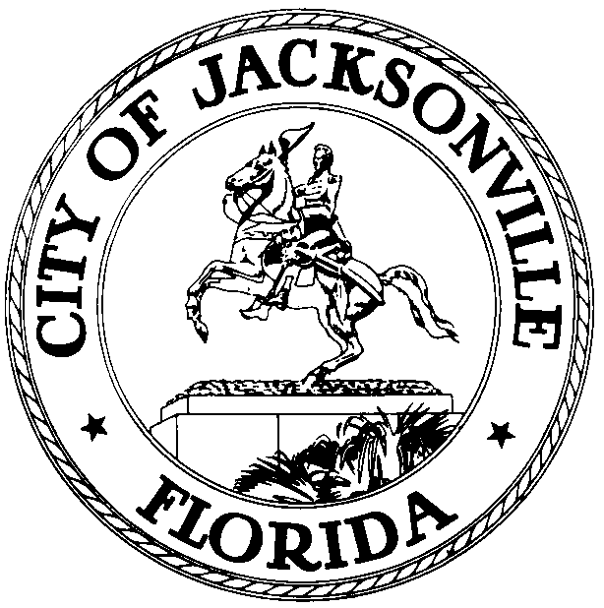
 | OFFICE OF THE CITY COUNCIL
DR. CHERYL L. BROWN  DIRECTOR- COUNCIL SECRETARY  JACKSONVILLE CITY COUNCIL |  | SUITE 425, CITY HALL  117 WEST DUVAL STREET  JACKSONVILLE, FLORDIA 32202
OFFICE (904) 630-1452 |  | E-MAIL: CLBROWN@COJ.NET
FAX (904) 630-2906

August 22, 2016
(5:00 P.M.)

Notice – Lunch and Learn Workshop

TO: Jacksonville City Council – Members
Jacksonville City Council - Staff

THRU: Honorable Lori N. Boyer, President
Jacksonville City Council

FR: Dr. Cheryl L. Brown, Director
Jacksonville City Council

RE: 09.12.2016 Brown Bag Lunch and Learn – City Council Webpage, Council Member District or At-Large Webpage, GIS Information and More Lunch and Learn

Notice is hereby given that Honorable Lori N. Boyer will host a Brown Bag Lunch and Learn Workshop with the Jacksonville City Council and Council Staff. The meeting will be held on Monday, September 12, 2016, 12:00 p.m. to 1:00 p.m., in the Lynwood Roberts Room – located at 117 West Duval Street, 1st Floor - City Hall, St. James Building, Jacksonville, Florida 32202.

The purpose workshop is to provide an overview of the our city council webpage- what can be included, how to update, links, newsletters, etc.; District information from about new projects on featured districts using GIS and other data driven information. Council Systems Information Administrators and Managers of Web, Audio and Visual personnel Rachael Merritt, Steve Cassada, Louie Marino, along with Council Director Cheryl L Brown, and Information Technologies Department Staff Paul Freeman, Enterprise Applications Manager, and Stephen Herczeg, Assistant Information Tech Officer –GIS Manager or their designee(s) will serve as the presenters for this activity.
All interested parties are invited.

Please contact Dr. Cheryl L. Brown at 904.630.1452 or CLBrown@coj.net for additional information.

cc: Carol Owens, Interim, Chief of Leg. Services Kyle Billy, Assistant Council Auditor
Dr. Cheryl L. Brown, Director City Council Jason R. Gabriel, General Counsel
Kirk Sherman, Council Auditor Jeffrey Clements, Chief of Research
Paige Johnston, OGC John J. Jackson, Research Assistant
Margaret “Peggy” Sidman, OGC Staff- Office of the Mayor
Council Member’s ECA’s Council Staff
File

