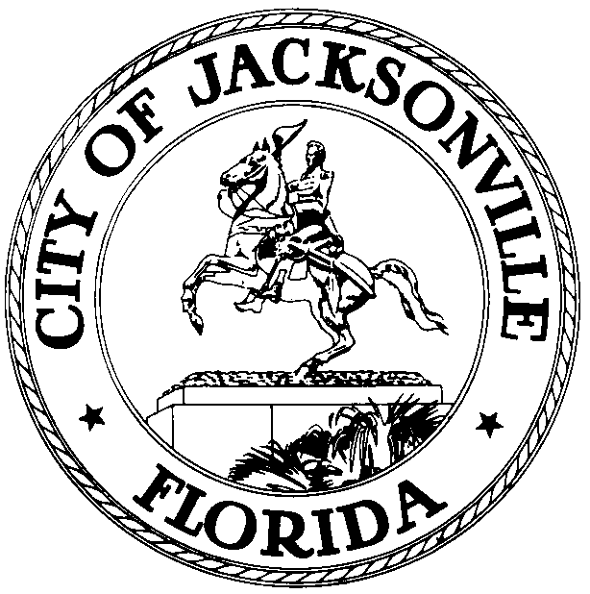

OFFICE OF THE CITY COUNCIL
AL FERRARO 117 WEST DUVAL STREET
COUNCILMEMBER, District 2 SUITE 425
OFFICE (904) 630-1392 JACKSONVILLE, FLORIDA
FAX (904) 630-3403 32202

January 25, 2016
5:00PM

NOTICE

Notice is hereby given that Council Member Al Ferraro will meet with Rev. Demps on Thursday, January 28th at 1:00PM in Conference Room “A”, located at 117 West Duval Street, Suite 425 City Hall St. James Building about support for a Gullah Geechee Museum. All interested City Council Members are requested to attend.

All interested persons are invited to attend.

Please contact Connie Holt, ECA-District 2, at (904) 630-1675 for additional information or correspondence.

AJF/clh

cc: Council Members/Staff
Cheryl L Brown, Director
Dana Farris, Chief –Legislative Services
Carol Owens, Assistant Chief – Legislative Services
Jeff Clements, Chief of Research
Kristi Sikes, Chief, Administrative Services Division
CITYC@COJ.NET
Office of General Counsel
Electronic Notice Kiosk – 1 Floor City Hall
Public Notice System – City Council Web Page
Media Box
File Copy

