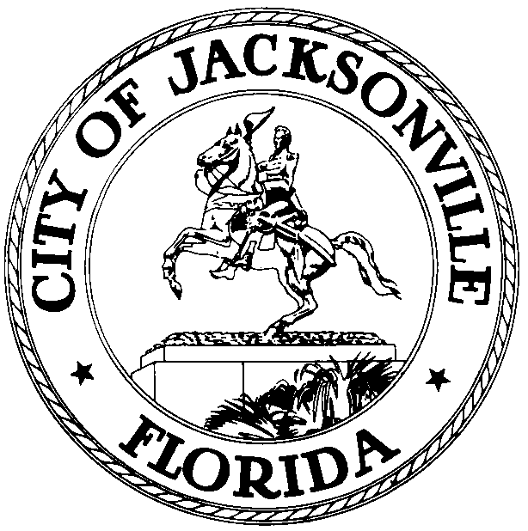
OFFICE OF THE CITY COUNCIL
MATT SCHELLENBERG  COUNCIL MEMBER, DISTRICT 6  OFFICE (904) 630-1388  FAX (904) 630-2906  E-MAIL: MATTS@COJ.NET |  | 117 West Duval Street  SUITE 425  JACKSONVILLE, FLORIDA  32202
January 19, 2016
11:45 a.m.

Meeting Notice

Notice is hereby given that Council Member Matt Schellenberg and Council Member Tommy Hazouri will meet on Monday, January 25, 2016, at 1:30 p.m. in Conference Room B, located at 117 West Duval Street, Suite 425, City Hall, Jacksonville, FL 32202. The meeting is to discuss Council Member Schellenberg’s candidacy for Vice President of the City Council.

All interested parties are encouraged to attend.

Please contact Audrey Braman, ECA, District 6, for additional information at 630-1388.

MMS/alb

cc: Council Members & Staff
Cheryl Brown, Director/Council Secretary
Dana Farris, Chief, Legislative Services Division
Jeff Clements, Chief, Research Division
Office of the General Counsel
CityC@coj.net
Posted Notice Board - 1st Floor City Hall
Posted Meeting - City Council Calendar
Electronic Notification - 1st Floor City Hall
Posting to Public Notices - City Council Web Page
Media Box

