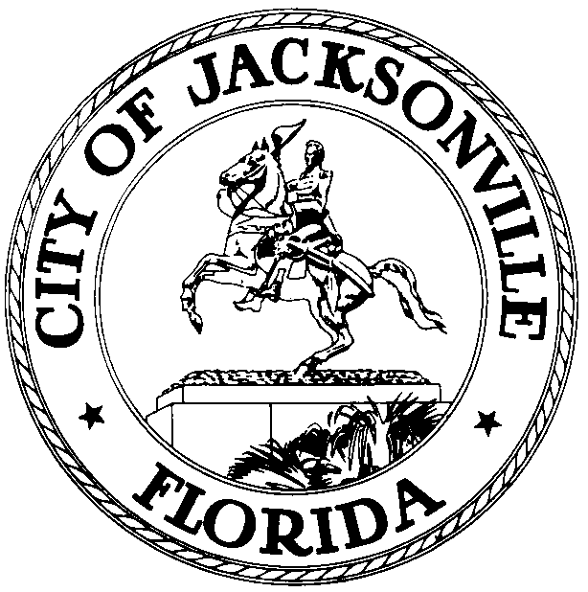

OFFICE OF THE CITY COUNCIL

DR. CHERYL L BROWN 117 WEST DUVAL STREET
DIRECTOR/COUNCIL SECRETARY 4th FLOOR – SUITE 425
OFFICE: 904-630-1452 JACKSONVILLE, FLORIDA 32202
FAX: 904-630-2906 EMAIL: CLBROWN@COJ>NET

NOTICE
September 17, 2015
5:00 PM

Notice is hereby given, the Jacksonville City Council Agenda Meeting normally scheduled for Tuesday, September 22, 2015 has been rescheduled one day earlier to Monday, September 21, 2015, beginning at 4:00 p.m. in the City Council Chamber- City Hall St. James Building- located 117 West Duval Street- 1st Floor Jacksonville, Florida 32202. The change of meeting date and time is due to the passage of Ordinance 2015-592-E, the Jacksonville City Council date and time change. The Committee Chairpersons will provide details of the actions taken during their Standing Committee Meetings.

All interested parties are welcome and encouraged to attend.

Please contact the Legislative Services Division, at (904) 630-1404, for additional information or correspondence.

CLB/JC/clb

xc: Council Members/Staff
Dr. Cheryl Brown, Director/Council Secretary
Kristi Sikes, Chief of Administration
Jeff Clements, Chief, Research Division
Dana Farris, Chief, Legislative Services Division
Carol Owens, Assistant Chief, Legislative Services Division
CITYC@COJ.NET
Media Box
File Copy

