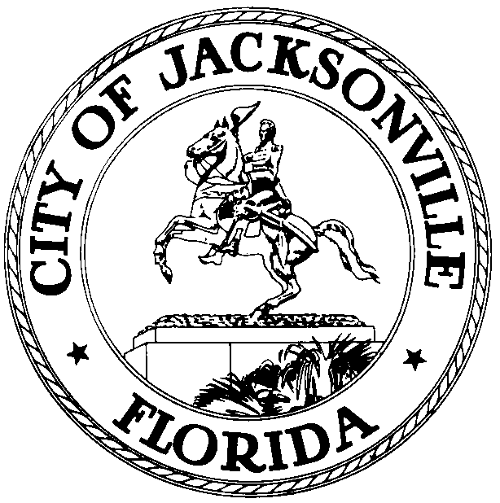

OFFICE OF THE CITY COUNCIL
DR. CHERYL L. BROWN 117 WEST DUVAL STREET, SUITE 425
DIRECTOR/COUNICL SECRETARY 4TH FLOOR, CITY HALL
OFFICE (904) 630-1452 JACKSONVILLE, FLORIDA 32202
FAX (904) 630-2960
E-MAIL: CLBROWN@COJ.NET
NOTICE

May 22, 2015
5:00 p.m.

In accordance with Section 15.108 (Annual continuing education and training on Sunshine Law requirements), Ordinance Code:

Notice is hereby given that Office of General Counsel, Ethics Officer, and Director of Jacksonville City Council will provide the annual continuing education and training on Government in the Sunshine and open meetings laws for the members of the City Council-Elect and Executive Council Assistants. Additionally, the City Council Members and Executive Council Assistants will attend scheduled meetings or Employee and Orientation as the new elected and appointed personnel for the City of Jacksonville: The meetings will be held on the following dates and locations: Wednesday – Friday - June 3-5, 2015, at 8:00 a.m. -Lynwood Roberts Room, located at 117 West Duval Street, 1st Floor City Hall St. James Bldg., Jacksonville, Florida. Breakout sessions will be held on the 1st Floor City Hall Council Chamber, Don Davis Room, and Committee Room B, for completion of Benefit Packets Processing.

Meetings will provide continuing education and training to the City Council Members and their Executive Council Assistants on Government in the Sunshine and open meetings laws. Meetings will also provide information on organizational structure and City of Jacksonville required Human Resources information for employment, parking and other administrative requirements for processing new personnel.

All interested parties are invited to attend.

Please contact Cheryl L Brown, Director City Council at 904.630.1452 or Margaret M. Sidman at 904.630.4647 for additional information or correspondence.

CLB/clb

XC: Council Members 2011-2015 and Council Staff Council Members Elect 2015-2019
Cheryl L. Brown, Director/Council Secretary- City of Jacksonville Duval County School Board Members
CITYC@COJ.NET Cleveland Ferguson, CAO – Office of Mayor
Angela Corey, State Attorney Stephanie Barnett, ITD
Jason Gabriel -General Counsel Calendar Posting
Carla Miller - Ethics Officer Electronic Notice Kiosk
City of Jacksonville Constitutional Officers Media
Baldwin, Atlantic Beach, Neptune Beach Elected Officials City Council Members Elect 2015-2019 and Staff
Margaret Sidman, Deputy General Counsel Paige Johnston, Assistant General Counsel
Dana Farris, Chief of Legislative Services Carol Owens, Asst. Chief of Legislative Services
Laura Dyer, Executive Administrator CC Rachel Merritt, Systems Administrator CC
Kristi Sikes, Chief of Administration CC Jeff Clements, Chief of Research CC
Steve Cassada, Systems Administrator Louie Marino, Systems Administrator
Teresa Eichner, Liaison Office of Mayor File Copy Ethics Commission – City of Jacksonville Kirk Sherman, Council Auditor
Kyle Billy, Assistant Council Auditor Public Notice System- City Council Web Page

