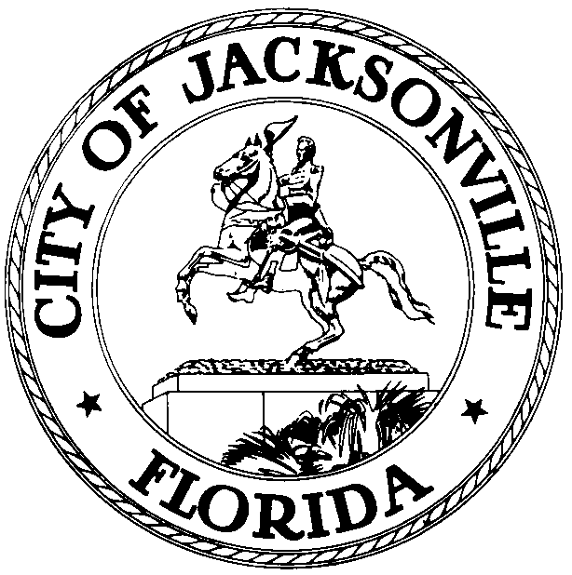
OFFICE OF THE CITY COUNCIL
JOHN CRESCIMBENI  COUNCIL MEMBER, AL-GROUP 2  OFFICE (904) 630-1381  FAX (904) 630-2906  E-MAIL: JRC@coj.net |  | 117 WEST DUVAL STREET  SUITE 425  JACKSONVILLE, FLORIDA  32202

May 4, 2015
(5:00 PM)

Amended Meeting Notice

Notice is hereby given that Council Member John Crescimbeni, Chair of the Special Economic Development Incentives Committee will not meet with Members Greg Anderson and Matt Schellenberg on Thursday, May 7th, 2015 at 9:00 a.m., this meeting has been rescheduled for Thursday, May 14th at 9:00 a.m., in Conference Room A, 4th Floor, Suite 425 – City Hall, 117 West Duval Street, Jacksonville, Florida, 32202.

Please mark your calendars accordingly. All interested parties are invited to attend.

Please contact Jessica Morales – Legislative Services Division at (904) 630-1404 for additional information or correspondence.

cc: Council Members/Staff
Cheryl Brown, Director
Dana Farris, Chief, Legislative Services Division
Carol Owens, Assistant Chief, Legislative Services Division
Jeff Clements, Chief of Research
Kirk Sherman, Council Auditor
Office of the General Counsel
CityC@coj.net
Posted Meeting – City Council Calendar
Electronic Notification – 1st Floor City Hall
Posting to Public Notices – City Council Web Page

Media Box
File Copy

