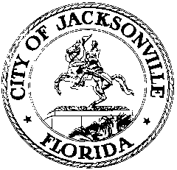

OFFICE OF THE CITY COUNCIL

Ray Holt 117 WEST DUVAL STREET
COUNCILMEMBER, District 11 SUITE 425
OFFICE (904) 630-1383 JACKSONVILLE, FLORIDA
FAX (904) 630-3403 32202
April 17, 2015
4:00 P.M.

M E M O R A N D U M

TO: The Honorable Steven Joost
The Honorable William Bishop
The Honorable Lori Boyer
The Honorable Jim Love
The Honorable Don Redman

FROM: Council Member Ray Holt, Chair
Land Use and Zoning Committee

RE: LUZ Committee Workshop April 21, 2015

Notice is hereby given that the Land Use & Zoning Committee will hold a Workshop on April 21, 2015, 3:30 P.M., Council Chambers, 117 W. Duval St, Jacksonville, Florida, to discuss the following:

WORKSHOP FOR ZONING AND LAND USE APPLICATIONS – CHANGES
- Process Improvement
- Website updating
- What are “conditions” to a PUD?
- What are NOT “conditions” to a PUD
- Allowing changes to rezoning application Sec. 656.122, Ord. Code

All interested parties are invited to attend. Please mark your calendars accordingly. Please contact Philip Zamarron, Legislative Assistant, at (904) 630-1404 for additional information or correspondence.

RH/SG/prz
cc: Council Members/Staff
Cheryl L. Brown, Director/Council Secretary
Dana Farris, Chief, Legislative Services Division
Carol Owens, Asst Chief, Legislative Services Division
Jeff Clements, Chief, Research Division
Kristi Sikes, Chief, Administrative Services Division
CITYC@COJ.NET
Posted Notice Board – 1st Floor City Hall
Electronic Notice Kiosk – 1st Floor City Hall
Public Notice System – City Council Web Page
Media Box
File Copy

