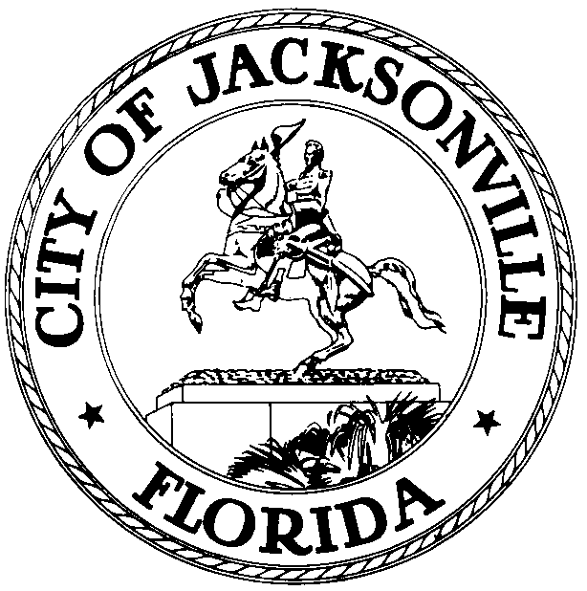

OFFICE OF THE CITY COUNCIL

CHERYL L. BROWN 117 WEST DUVAL STREET, SUITE 425
DIRECTOR 4TH FLOOR, CITY HALL
OFFICE (904) 630-1452 JACKSONVILLE, FLORIDA 32202
FAX (904) 630-2906
E-MAIL: CLBROWN@coj.net

Special Economic Development Incentives Committee Meeting Minutes
April 8, 2015
9:00 a.m.

Location: City Council Conference Room A, Suite 425, City Hall – St. James Building; 117 West Duval Street

In attendance: Council Members John Crescimbeni (Chair), Greg Anderson, Matt Schellenberg (arr. 9:30 a.m.)

Also: Council Members Warren Jones and Lori Boyer (arr. 9:22); Heather Reber – Council Auditor’s Office; Jessica Morales – Legislative Services Division; Peggy Sidman – Office of General Counsel; Jeff Clements – Council Research Division; Ted Carter and Paul Crawford – Office of Economic Development

See attached sign-in sheet for additional attendees.

Meeting Convened: 9:16 a.m.

Council Member Crescimbeni convened the meeting and the attendees introduced themselves for the record.

Ted Carter, Executive Director of the Office of Economic Development, followed up on items from the previous meeting, including the location of the City’s enterprise zones, the enterprise zone incentive projects over the last 10 years and the residential location of the employees hired. Joe Whitaker of the OED noted that the enterprise zone program appears that it will not be renewed by the Florida Legislature and the program will sunset as of December 31, 2015. The City will be required to pay out the remainder of enterprise zone incentives that have already been granted, but no new incentives can be granted as the program phases out. Ed Randolph reported that the hiring of employees residing within the enterprise zone is verified by the state Department of Revenue and the City does not get detailed reports of the residence locations of particular employees or particular companies. Council Member Brown stated that the City’s $1,000 enterprise zone residence bonus has not attracted any takers so he is considering introducing legislation to increase the amount of the bonus to make it more attractive. The committee discussed potential reasons why companies have difficulty finding suitable employees residing within the enterprise zone. Lack of training and basic job skills are frequently cited by employers as hiring impediments.

Council Member Boyer requested further information on the compliance of the incentivized companies with each of the aspects of their incentives, some of which are capital investment-based and others of which are job creation-based. She suggested the possibility of implementing staggered scales for incentives for varying levels of job creation so that the size of the incentive increases for companies that produce greater numbers of jobs. If job creation is not the major feature of an economic prospect, then perhaps a different set of incentives would be in order.

The OED staff is still working on a draft of a standardized incentive project report for presentation at a future meeting. Paul Crawford outlined the various factors that will be included in the template document.

Council Member-elect Aaron Bowman stated that JAXUSA Partnership is in competition for several projects that are attractive companies but have relatively low capital investment levels that would not meet the City’s current minimum standard for $10 million in capital investment and therefore would not be eligible for investment-based incentives. He suggested that the threshold be reduced to $1 million to accommodate more of these prospects. In response to a question, Mr. Bowman stated that different incentives are more or less important to different companies based on their particular business model, employee needs, and other factors. Council Member Schellenberg was favorably disposed to incentivizing small companies in hopes of growing them into larger companies over time. Council Member Anderson suggested that the definition of “small company” should be based more on revenue than on number of employees. A hybrid definition was also suggested, combining employment, capital investment and revenue.

In response to a question from Council Member Boyer, Mr. Crawford said that the OED’s analysis of economic prospects will consider primarily direct economic impacts (tax revenue to the City) with additional discussion of indirect impacts from secondary and tertiary employment and economic multipliers where that may be relevant. Several committee members expressed reservations about calculations of indirect economic impact and reluctance to factor that into the incentive process. Peggy Sidman stated that she is in the process of drafting legislation to reinvigorate the Job Opportunity Bank board by appointing new members and has learned in that process that there are a couple of hundred thousand dollars available to pay for targeted training.

Paul Crawford discussed potential funding amounts for new incentive programs. The funding amounts are based on the assumption of increasing City-incentivized employment by 15% and increasing capital investment by 10% over the average of the previous 5 years. Incentives targeted to manufacturing companies would be considered separately because manufacturing companies tend to be more capital intensive compared to the number of jobs created. The model will outline costs per job and revenues per job and will project ad valorem revenues and incentive pay-outs over the length of the incentive period. Early projections based on initial assumptions indicate that the OED may be requesting approximately $300,000 of additional funding for incentives each year for the next two fiscal years.

Mr. Crescimbeni directed the OED staff to meet with Council Member Schellenberg in the next week to discuss the funding needs projections and other items of interest.

Public comment
Carnell Oliver said that the federal Department of Education has made available new funding for apprenticeship programs that FSCJ is exploring and urged greater investment in workforce preparedness and job training to improve the employability of the City’s workforce.

Next meeting
April 23, 2015 at 9:00 a.m.

Meeting Adjourned: 10:31 a.m.

Minutes: Jeff Clements, Council Research Division
4.8.15 Posted 11:00 a.m.
Tapes: Economic Development Incentives Committee – LSD
4.8.15
Materials: Economic Development Incentives Committee handouts
4.8.15

