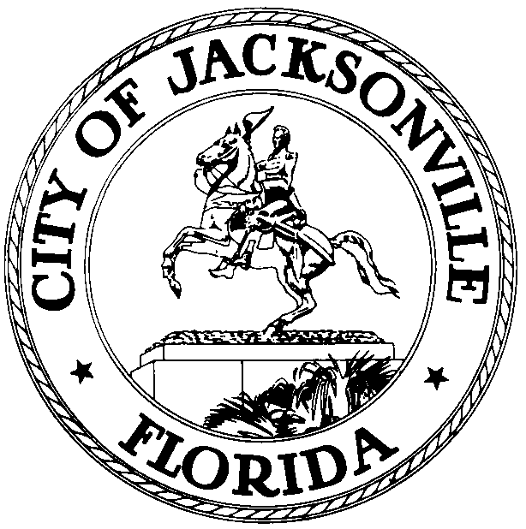

OFFICE OF THE CITY COUNCIL

CHERYL L. BROWN 117 WEST DUVAL STREET, SUITE 425
DIRECTOR 4TH FLOOR, CITY HALL
OFFICE (904) 630-1452 JACKSONVILLE, FLORIDA 32202
FAX (904) 630-2906
E-MAIL: CLBROWN@coj.net

Special Economic Development Incentives Committee Meeting Minutes
January 15, 2015
9:30 a.m.

Location: City Council Conference Room A, Suite 425, City Hall – St. James Building; 117 West Duval Street

In attendance: Council Members John Crescimbeni (Chair), Matt Schellenberg, Greg Anderson

Also: Council Member Lori Boyer; Kyle Billy and Heather Reber – Council Auditor’s Office; Carol Owens and Jessica Morales – Legislative Services Division; Peggy Sidman – Office of General Counsel; Jeff Clements – Council Research Division

See attached sign-in sheet for additional attendees.

Meeting Convened: 9:33 p.m.

Council Member Crescimbeni convened the meeting and the attendees introduced themselves for the record.

Ted Carter, Executive Director of the Office of Economic Development, reviewed the state of the Jacksonville economy and the OED’s incentive project success from calendar year 2014. Economic activity is increasing, downtown property sales are showing positive trends, tourism is increasing and hotel occupancy and room rates are increasing. 2014 was a good year for corporate relocations and expansions, including major multi-nationals such as General Electric and Adecco. The Mayor has requested the OED to increase its focus on international trade and export activity in 2015. Small business, workforce development and film and television production will also see enhanced efforts in the coming year.

Jerry Mallot of the JaxUSA Partnership said that recruiting activity is going well and the partnership intends to expand its efforts by reaching out to 10 important companies in each of its 6 business target areas to tell Jacksonville’s story and to see if there is any interest in considering Jacksonville for a location or expansion. The mayor wants the OED and JaxUSA Partnership to go on the offensive and reach out to companies rather than waiting for companies or site selectors to come to the city. JaxUSA actively engages with site selectors because of their importance in the corporate location process. Mr. Carter distributed copies of a report by the Milliken Institute showing Jacksonville’s substantial improvement in job creation metrics from 2013 to 2014.

Paul Crawford, Deputy Director of the OED, discussed the committee’s previous work in the last Council year before the committee went on hiatus in mis-2014 and offered to re-provide any of the information from the committee’s earlier work.

Amy Holloway of Avalanche Consulting presented the results of the company’s study of Jacksonville’s economic incentive policies in 2014. She noted that economic activity nationwide spurted in 2012 and 2013 reflecting pent-up demand following the 2008-09 recession, then slowed down somewhat in 2014. Many of the new business development projects produce fewer jobs than in years past as increasing automation and technological development reduce the number of personnel needed by companies. She noted that the benchmark communities against which Jacksonville’s incentive program was compared were Atlanta, Austin, Charlotte, Dallas, Savannah, Tampa and Virginia Beach. Perspectives on economic development incentives vary considerably from companies and site selectors to elected officials to citizens, all of whom have very different interests and desired outcomes. Ease and speed of the incentive review and award process from the corporate perspective are not incompatible with transparency and public accountability from the public perspective.

Avalanche’s general recommendations include: combining and streamlining some incentive programs for simplicity and branding; seeding programs with cash for infrastructure improvement and workforce development; providing for fee waivers; ensuring project confidentiality during the public review process; and collapsing local and state compliance requirements into a unified report when possible for uniformity and simplicity. Ms. Holloway noted that workforce development is a top-of-the-list concern for most companies today and programs in that area are very important for corporate prospects. Jerry Mallot said that relocation prospects today generally assume that jurisdictions will waive building and development permitting fees as a matter of course; it’s standard practice nationwide. Council Member Boyer cautioned that fees such as the mobility fee may not be easily susceptible to waiver since they are based on a calculation that shares large roadway development costs among all developers on a fair and uniform basis. She also questioned whether the JEA has a policy regarding waiver of utility capacity reservation fees. Wayne Young of the JEA said that two years ago the utility developed 3 types of economic incentive discounts and is willing to consider incentives outside the parameters of those programs on a case-by-case basis in unusual circumstances.

Recommendations for Northwest Jacksonville and other areas of special opportunity include: create a community development entity; consider pursuing New Market tax credits; bring new small business development center services and a microloan program to Northwest Jacksonville; establish a Business Enterprise Center in the area; promote food banks and culinary programs in the “food desert” area; establish a revolving loan fund; and offer a bonus incentive to companies locating in economically disadvantaged areas.

Downtown-specific recommendations included: expanding the façade program and incentives for renovations; condensing approval time frames, assigning OED staff to assist DIA; creating a fee waiver program; and being supportive of new co-work and incubator business space in downtown. Aundra Wallace, Executive Director of the Downtown Investment Authority, gave an overview of the DIA’s new retail renovation grant program for tenant improvements to attract new retail to vacant downtown buildings.

Recommendations for film/television incentives include: working with the state to renew and expand state incentive programs for film and TV; adopting local incentives such as cash rebates and tax credits.

Thoughts on compliance include: balance the need for compliance with simplification and streamlining of requirements; include clawback provisions; craft requirements to meet stated goals – specifically incentivize what you want.

National incentive trends: flexibility equals opportunity – offer fewer but more effective programs; cash is king – cash closing funds are increasingly common; talent talks – access to a talented workforce is a huge incentive and workforce development/training is valuable; live by the ROI (return on investment) – determine what you want your return to be and don’t incentivize projects that don’t produce a sufficient return, only making exceptions in unusual circumstances for valid reasons. ROI includes many factors beyond simple financial return such as building career opportunities for all residents, increasing awareness of the region in the national and international marketplace, benefits to local supply chain, vendors, port, etc.

Concerns with the City’s current Project Evaluation Matrix (PEM) include: complexity; lack of uniformity with state evaluation form. Recommendations include: create a return on investment-based PEM; utilize a “stackable” set of incentives that include additional benefits for locating in preferred development areas.

In response to a question from Chairman Crescimbeni about what incentives other states offer that Florida and Jacksonville don’t offer, Ms. Holloway cited workforce development programs; otherwise the state and city are fairly comparable with other competitor cities. A greater investment in higher education by the State of Florida would be helpful from a statewide competitive standpoint. In response to a question from Assistant Council Auditor Kyle Billy about the relative merits of waiving the City’s investment policies to meet specific prospect requests that don’t fit the standard policy versus amending the policies to expand the standards to avoid making exceptions, Jerry Mallot expressed a preference for keeping the general policy more restrictive and granting exceptions where warranted. That keeps prospect expectations lower at the outset than if the incentives were expanded.

Ted Carter said that the OED is working on 3 or 4 additional programs that need to be presented to the Council for approval, but the discussion about revising the incentive policies is ready to be had.

The next meeting will be on February 12th and will include a presentation by the Film and Television Office and the start of discussions on proposed amendments to the Public Investment Policy.

Meeting Adjourned: 11:26 a.m.

Minutes: Jeff Clements, Council Research Division
1.15.15 Posted 12:00 p.m.
Tapes: Economic Development Incentives Committee – LSD
1.15.15
Materials: Economic Development Incentives Committee handouts
1.15.15

