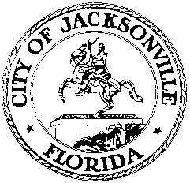

OFFICE OF THE CITY COUNCIL

CHERYL L. BROWN 117 WEST DUVAL STREET, SUITE 425
DIRECTOR 4TH FLOOR, CITY HALL
OFFICE (904) 630-1452 JACKSONVILLE, FLORIDA 32202
FAX (904) 630-2906
E-MAIL: CLBROWN@coj.net

AD HOC REFERENDUM FISCAL IMPACT ESTIMATE COMMITTEE
FOR ORDINANCES 2014-151-E AND 2014-681-E
MEETING NOTICE – DECEMBER 18, 2014

Notice is hereby given that the Ad Hoc Referendum Fiscal Impact Estimate Committee mandated by provision of City Charter Section 18.05(k) to estimate the potential fiscal impact of the Charter amendment to impose a residency requirement on all employees and appointees of the City of Jacksonville, its constitutional officers and independent authorities as authorized by Ordinance 2014-151-E (and subsequently amended by Ordinance 2014-681-E) will meet on Thursday, December 18, 2014 at 10:00 a.m. in City Council Conference Room B to begin its deliberations.

All interested parties are invited to attend.

cc: Council Members/Staff
Cheryl Brown, Director
Dana Farris, Chief, Legislative Services Division
Carol Owens, Assistant Chief, Legislative Services Division
Jeff Clements, Chief of Research
Kirk Sherman, Council Auditor
Office of the General Counsel
CityC@coj.net
Posted Notice Board – 1st Floor City Hall
Posted Meeting – City Council Calendar
Electronic Notification – 1st Floor City Hall
Posting to Public Notices – City Council Web Page
Media Box
File Copy

Posted 12.8.14 5:00 p.m.
Jeff Clements, City Council Research

