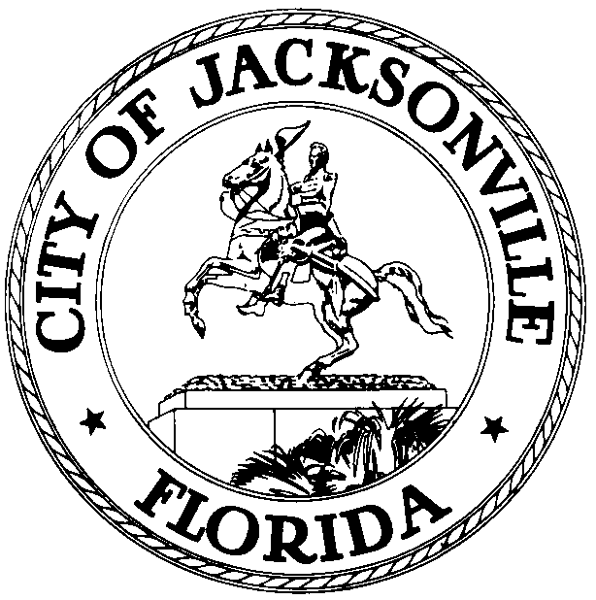
OFFICE OF THE CITY COUNCIL
WILLIAM BISHOP, AIA  PAST PRESIDENT 2012-2013  COUNCIL MEMBER, DISTRICT 2  OFFICE (904) 630-1392  FAX (904) 630-2906  E-MAIL: wbishop@coj.net |  | 117 West Duval Street  SUITE 425  JACKSONVILLE, FLORIDA  32202
June 5, 2014
4:45 p.m.

Meeting Notice

Notice is hereby given that Council Member Bill Bishop, will meet with Folks Huxford, Chief of Current Planning and Mike Sands, Chief of Development Services; Planning & Development Department and Jason Gabriel, Assistant General Counsel on 2013-64-E, Rawl’s Landing PUD, on Tuesday, June 10, 2014, at 1:30 p.m., in the Don Davis Room, 1st Floor, City Hall at St. James. The purpose of the meeting is to review the permitting status and mitigation procedures.

2013-64-E AN ORDINANCE REZONING APPROXIMATELY 12± ACRES LOCATED IN COUNCIL DISTRICT 2 ON GIrvin road BETWEEN Mt. pleasant road AND Ebbtide court (R.E. NO(s). 160924-0000, 162181-0000, 162182-0000 and 162183-0000), AS DESCRIBED HEREIN, OWNED BY rawls landscape of jax., inc. and rawls land, llc, FROM rr-acre (residential rural-ACRE) DISTRICT TO PUD (PLANNED UNIT DEVELOPMENT) DISTRICT, AS DEFINED AND CLASSIFIED UNDER THE ZONING CODE, to permit single family residential uses, AS DESCRIBED IN THE APPROVED WRITTEN DESCRIPTION AND SITE PLAN FOR THE rawls landing PUD; Pud rezoning subject to conditions..

All interested parties are encouraged to attend.

Please contact Suzanne Warren, ECA, District 2, for additional information at 630-1392.

cc: Council Members & Staff
Cheryl Brown, Director/Council Secretary
Dana Farris, Chief, Legislative Services Division
Jeff Clements, Chief, Research Division
Office of the General Counsel
Cityc@coj.net
Posted Notice Board - 1st Floor City Hall
Posted Meeting - City Council Calendar
Electronic Notification - 1st Floor City Hall
Posting to Public Notices - City Council Web Page
Media Box

