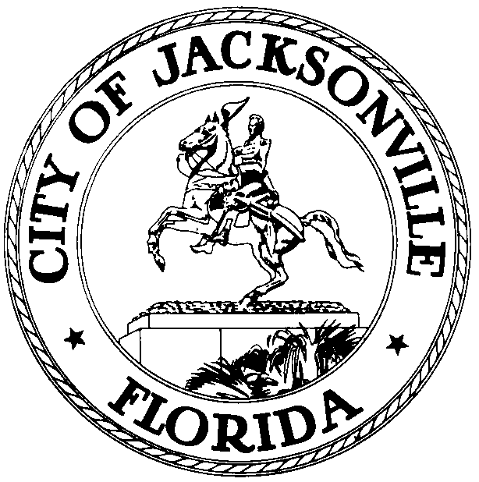

OFFICE OF THE CITY COUNCIL

GREG ANDERSON  COUNCIL MEMBER  AT-LARGE, GROUP 4  OFFICE (904) 630-1398  FAX (904) 630-2906 |  | SUITE 425, CITY HALL  117 WEST DUVAL STREET  JACKSONVILLE, FLORIDA 32202  E-MAIL:GANDERSON@coj.net

May 19, 2014
5:00 p.m.

***CANCELLATION MEETING NOTICE***

Council Member Greg Anderson will be meeting with Council Member Doyle Carter to discuss Ordinance 2014-0303.

“AN ORDINANCE NAMING THE NEW STATE ATTORNEY’S OFFICE LOCATED AT 311 WEST MONROE STREET, JACKSONVILLE, FLORIDA 32202, AS THE ‘T. EDWARD AUSTIN STATE ATTORNEY’S OFFICE.’ ”

The meeting will take place on Tuesday, May 20, 2014, 1:00 p.m., in Conference Room A, Suite 425, City Hall, 117 West Duval Street, Jacksonville, Florida 32202. This meeting is open to all Council Member who are interested in this topic. This meeting has been cancelled.

All interested parties are invited to attend.

Please contact Leeann Krieg, ECA, at (904) 630-1678 for additional information or correspondence.

GA/lk

cc: Council Members/Staff
Cheryl L. Brown, Director/Council Secretary
Dana Farris, Chief – Legislative Services Division
Carol Owens, Assistant Chief – Legislative Services Division
Jeff Clements, Chief, Research Division
Kristi Sikes, Chief, Administrative Services Division
CITYC@COJ.NET
Electronic Notice Kiosk – 1st Floor City Hall
Public Notice System – City Council Web Page
Media Box
File Copy

