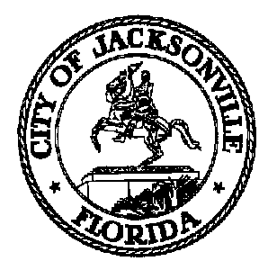

OFFICE OF THE CITY COUNCIL

Lori N. Boyer, Council Member 117 W. Duval Street, Suite 425
District 5 4th Floor, City Hall – St. James Bldg.
Phone (904) 630-1382 Jacksonville, Florida 32202
Fax (904) 630-2906
E-Mail: LBOYER@coj.net

TASK FORCE ON CONSOLIDATED GOVERNMENT

(ORGANIZATION & OPERATIONS SUBCOMMITTEE)

Meeting Notice

February 21, 2014
9:00 p.m.

TO: Organization & Operations Subcommittee Chair Elaine Brown and Vice Chair Kerri Stewart

FROM: Council Member Lori Boyer, Chair

SUBJECT: Organization & Operations Subcomm Work Plan & Time Line Mtg 2.24.14

Notice is hereby given that the Task Force on Consolidated Government Organization and Operations Subcommittee Chair, Elaine Brown and Vice Chair Kerri Stewart will meet in Conference Room B, located at 117 W. Duval St., 4th Floor, Suite 430, City Hall - St. James Building on Monday, February 24, 2014 from 9:30 A.M. until 11:30 A.M. Purpose of the meeting is to discuss the subcommittee’s work plan and timeline. Please mark your calendars accordingly.

When attending these meetings, members are to park in the parking garage located on the corner of Main and Duval Street (Library Garage) to receive free parking. Please see Cheryl Brown or Jeff Clements at each meeting for parking validation.

cc: Cheryl Brown, Council Director
Dana Farris, Chief of Legislative Services
Jeff Clements, Chief of Research
Rachel Welsh, System Information Administrator
Damian Cook, Task Force Staff Support
File
cityc@coj.net

/tmp/in/input.doc

