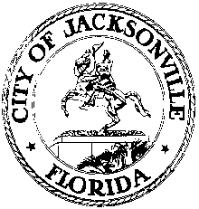

OFFICE OF THE CITY COUNCIL

SUITE 425, CITY HALL
117 WEST DUVAL STREET
JACKSONVILLE, FLORIDA 32202

February 19, 2014
9:00 A.M.

M E M O R A N D U M

TO: The Honorable John Crescimbeni
Peggy Sidman, Office of General Counsel
Ronnie Belton, CFO
Kevin Hyde, Foley & Lardner

FROM: Kirk Sherman, Chair
Ad Hoc Referendum Fiscal Impact Committee

RE: 2.20.14 Ad Hoc Referendum Fiscal Impact Committee meeting notice

Notice is hereby given that the Ad Hoc Referendum Fiscal Impact Committee will meet on Thursday, February 20 2014 at 9:00 A.M. in City Council Conference Room B, Suite 425, City Hall, 117 W. Duval St, Jacksonville, Florida, for the purpose of examining the fiscal impact of the proposed Charter amendment to create a library independent taxing district.

All interested parties are invited to attend. Please mark your calendars accordingly. Contact Jeff Clements, City Council Research at (904) 630-1405 for information.

JRC
cc: Council Members/Staff
Cheryl L. Brown, Director/Council Secretary
Dana Farris, Chief, Legislative Services Division
Carol Owens, Asst Chief, Legislative Services Division
Jeff Clements, Chief, Research Division
Kristi Sikes, Chief, Administrative Services Division
CITYC@COJ.NET
Posted Notice Board – 1st Floor City Hall
Electronic Notice Kiosk – 1st Floor City Hall
Public Notice System – City Council Web Page
Media Box
File Copy

