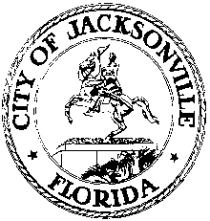

OFFICE OF THE CITY COUNCIL

SUITE 425, CITY HALL
117 WEST DUVAL STREET
JACKSONVILLE, FLORIDA 32202

February 10, 2014
12:00 P.M.

M E M O R A N D U M

TO: The Honorable John Crescimbeni
Peggy Sidman, Office of General Counsel
Ronnie Belton, CFO
Former Council President Kevin Hyde

FROM: Kirk Sherman, Chair
Ad Hoc Referendum Fiscal Impact Committee

RE: Ad Hoc Referendum Fiscal Impact Committee meeting notice

Notice is hereby given that the Ad Hoc Referendum Fiscal Impact Committee will meet on Wednesday, February 12, 2014 at 8:30 A.M. in City Council Committee Room B, 1st floor, City Hall, 117 W. Duval St, Jacksonville, Florida, for the purpose of examining the fiscal impact of the straw ballot on the proposed Charter amendment to create a library independent taxing district.

All interested parties are invited to attend. Please mark your calendars accordingly. Contact Jeff Clements, City Council Research at (904) 630-1405 for information.

JRC
cc: Council Members/Staff
Cheryl L. Brown, Director/Council Secretary
Dana Farris, Chief, Legislative Services Division
Carol Owens, Asst Chief, Legislative Services Division
Jeff Clements, Chief, Research Division
Kristi Sikes, Chief, Administrative Services Division
CITYC@COJ.NET
Posted Notice Board – 1st Floor City Hall
Electronic Notice Kiosk – 1st Floor City Hall
Public Notice System – City Council Web Page
Media Box
File Copy

