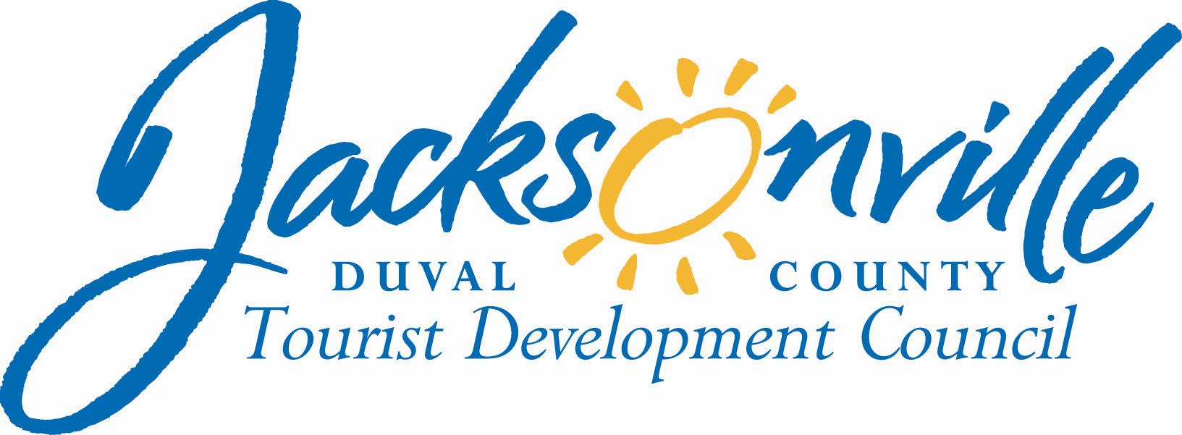

OFFICE OF THE CITY COUNCIL

Annette R. Hastings 117 WEST DUVAL STREET, SUITE 425
TDC EXECUTIVE DIRECTOR 4TH FLOOR, CITY HALL
OFFICE (904) 630-7625 JACKSONVILLE, FLORIDA 32202
FAX (904) 630-2906
E-MAIL: ANNETTEH@coj.net
January 27, 2014
(5:00 p.m.)

NOTICE
M E M O R A N D U M

TO: Duval Council Tourist Development Council Member Fred Pozin
Duval Council Tourist Development Council Member Barbara Goodman
Duval Council Tourist Development Council Chairman Bill Gulliford

FROM: Council Member Warren Jones
Chairman, Tourist Development Council Policy Subcommittee

SUBJECT: TDC Subcommittee Meeting on Policy
______________________________________________________________________________________

Notice is hereby given that Council Member Warren Jones, Chairman of the Duval County Tourist Development Council Policy Subcommittee, will meet with Tourist Development Council Subcommittee Members Fred Pozin, Barbara Goodman, and Chairman, Bill Gulliford. The meeting is scheduled for Monday, February 10, 2014 at 10:00a.m. The purpose of the meeting will be to discuss a codifying policy for TDC grant funding. The meeting will be held at City Hall at the St. James Building, 117 W. Duval Street, Fourth Floor, Suite 425, Conference Room A.

All interested parties are welcome to attend.

Please contact Annette R. Hastings, TDC Executive Director, at (904) 630-7625 if you cannot attend, or need additional information or correspondence.

SJ/arh
cc: Council Members/Staff
Cheryl L. Brown, Director/Council Secretary
Dana Farris, Chief -Legislative Services
Carol Owens, Assistant Chief – Legislative Services
Jeff Clements, Chief of Research
CITYC@COJ.NET
Janice Billy, Assistant Council Auditor
James McCain, Jr., Assistant General Counsel
Posted Notice Board – 1st Floor City Hall
Electronic Notice Kiosk – 1st Floor City Hall
Public Notice System – City Council Web Page
Media Box
File Copy

