 | 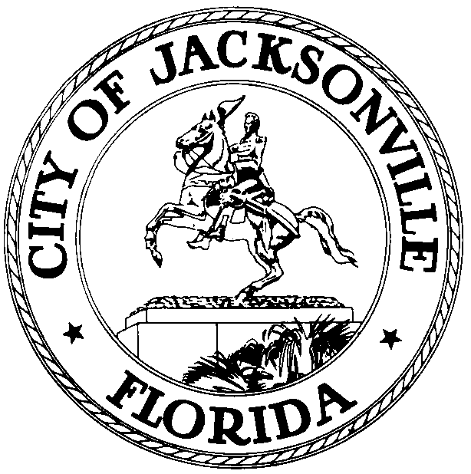
 | OFFICE OF THE CITY COUNCIL
CLAY YARBOROUGH |  | SUITE 425, CITY HALL
COUNCIL MEMBER, DISTRICT 1 |  | 117 WEST DUVAL STREET
OFFICE (904) 630-1389 |  | JACKSONVILLE, FLORIDA 32202
FAX (904) 630-2906 |  | E-MAIL: CLAY@COJ.NET

JOINT MEETING OF SPECIAL REORGANIZATION REVIEW COMMITTEE,
RULES AND FINANCE COMMITTEE

January 22, 2014
(5:00 PM)

TO: Rules Committee Members
Finance Committee Members

FROM: Clay Yarborough, Chair - Special Reorganization Review Committee
Warren Jones, Chair – Rules Committee
Greg Anderson, Chair – Finance Committee

RE: Joint Meeting of the Special Reorganization Review Committee, Rules & Finance Committee 1.27.14

Notice is hereby given that the Special Reorganization Review Committee Chair Clay Yarborough, has hereby called a Joint Meeting of the Special Reorganization Review Committee, Rules & Finance Committee to discuss, review, examine and make recommendation(s) to Council committees and the full Council as it relates to reorganization of City departments and divisions on Monday, January 27, 2014 at 4:00 PM, Council Chambers, 1st Floor, 117 West Duval Street, Jacksonville, Florida, 32202.

2013-209 ORD-MC Amend Var Chapts & Secs of Ord Code by Reorganizing & Renaming var Depts & Divisions, including Chapt 28 (Parks & Rec), Chapt 30 (Planning & Dev Dept), Chapt 32 (Public Works Dept), Chapt 35 (Neighborhoods Dept), Chapt 55 (Economic Dev), Chapt 23 (Intra-Govt'l Svcs Dept), by moving Divisions to other Depts or Consolidating Divisions; Provide Effective Date of 10/1/13. (Sidman) (Req of Mayor)

Please mark your calendars accordingly. All interested parties are invited to attend.

Please contact Marilyn Allen, Legislative Assistant, at (904) 630-1404 for additional information or correspondence.

CY/ma

cc: Council Members/Staff
Cheryl L. Brown, Director/Council Secretary
Dana Farris, Chief – Legislative Services Division
Carol Owens, Assistant Chief – Legislative Services Division
Jeff Clements, Chief, Research Division
Kristi Sikes, Chief, Administrative Services Division
Office of General Counsel
CITYC@COJ.NET
Electronic Notice Kiosk – 1st Floor City Hall
Public Notice System – City Council Web Page
Media Box

