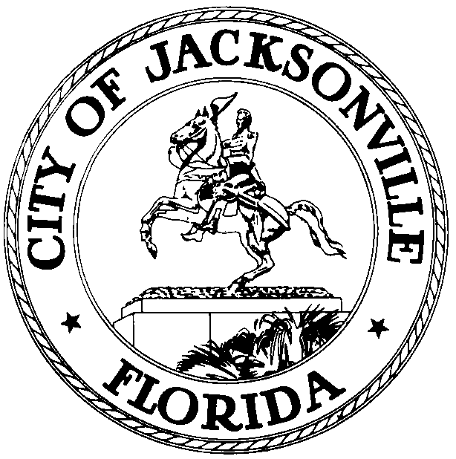

OFFICE OF THE CITY COUNCIL

CHERYL L. BROWN 117 WEST DUVAL STREET, SUITE 425
DIRECTOR 4TH FLOOR, CITY HALL
OFFICE (904) 630-1452 JACKSONVILLE, FLORIDA 32202
FAX (904) 630-2906
E-MAIL: CLBROWN@coj.net

Consolidation Review Task Force – Governance and Mission Committee
Meeting Minutes
January 16, 2014
9:00 a.m.

Location: Conference Room A, Suite 425, City Hall – St. James Building; 117 West Duval Street,

In attendance: Peter Rummel (Chair), Lad Daniels, Georgette Dumont, Michael Munz, Jim Rinaman, Dwain Senterfitt, Leon Carrero, Tony Hill, Cynthia Austin

Also: Task Force Chair Lori Boyer, Damian Cook – Task Force Administrator

See attached sign-in sheet for additional attendees

Meeting Convened: 9:06 a.m.

Chairman Rummell convened the meeting and said that the purpose of the committee was to talk about structural issues regarding the JTA and the JEA, not “people” issues, although there will be a natural tendency to want to stray into discussion of particular personalities.

Donna Harper, newly-elected Chair of the JTA board of directors, noted that JTA’s executive director has been on the job for one year and is still getting acclimated to how the JTA operates within the framework of Florida state law and the working relationship between the CEO and the board. She had several suggestions for the City regarding relations with its independent authorities: 1) establish a plan for continuous review of the operation of the consolidated government; 2) create an oversight process for independent authority board appointments to determine what sorts of skills are needed for each particular board and to evaluate potential nominees against the needed skill sets; and 3) each independent authority should have a new board member orientation process, both to hear from current or outgoing board members as to pending issues and overall expectations, and to hear from the City about how the authority fits into the larger framework of the City and the other authorities.

In response to questions, Ms. Harper indicated that the hiring of a new CEO has given the board an opportunity to redefine its role in relation to the CEO and staff, which was a needed exercise. She said the JTA board chair and CEO have traditionally met monthly with the Mayor and feels the JTA has worked well with the City on many issues over the years, even when it wasn’t to JTA’s financial benefit (shuttle service to Jaguar games, transportation to the Jazz Festival) and that the JTA and City have been good partners on pursuing the Better Jacksonville Plan projects. She would like to see a closer relationship between the JTA and all city council members, not just the council’s designated liaison member. JTA’s relationship with the North Florida TPO is a measure of the authority’s interest in regional affairs and a regional multi-county transportation commission has been created by the Florida Legislature. At present the body only has funding for administrative functions, not capital or operations. If the group does not come up with a dedicated funding source within 5 years then the commission may be sunset at the discretion of the legislature. Other counties are generally agreeable to the JTA coordinating transit functions, but are leery of giving JTA authority over road building in their jurisdictions. The partner counties worry that the JTA will be too Jacksonville-centric to adequately serve the needs of all counties fairly. The group discussed the differing needs and interests of the JTA as a service provider with responsibilities within Jacksonville and as part of a larger regional partnership.

Cynthia Austin who served on both the JTA and JEA boards noted that each authority has its own “silos” with regard to relations to the other authorities and to the City – there is a need for better integration of missions and operations among all parties. Each authority has a unique business, but all of them should be serving an overall integrated plan for furthering the future of the City as a whole. When she chaired the JEA she used to host quarterly meetings of the board chairs and CEOs of all the authorities to share ideas and concerns. She suggested that the authority leadership could jointly review the qualifications of potential candidates for board positions and recommend where their particular background and skills could be best put to use. Board development and training are very important given the size, complexity and budgets of the authorities.

Lori Boyer suggested the need for all the authority boards and the mayor to meet at least every 4 years at the start of a mayoral term to jointly agree on a coordinated vision for the next 4 years. Each party would still have its own particular mission, but the missions would coordinate within the umbrella of a unified vision for progress in the city. There was discussion of who develops the unified vision – the strong mayor form of government implies that it will be the mayor, but he/she can’t implement many parts of their vision without the cooperation of the authorities that are governed by their own boards, some of whom are partially appointed by state agencies. Margo Klosterman of the Mayor’s Office said that the Mayor meets quarterly with the CEOs of the authorities and has tried to convene semi-annual meetings of the authority leadership (CEOs and board chairs) with representatives of the Chamber of Commerce and Civic Council, but has been unsuccessful due to the difficulty of meshing the schedules of so many people. Michael Munz argued for the importance of developing some permanent structure to ensure that the meeting and cooperation take place and not depending on the good will of individual participants who change over time.

Peter Bower, a member of the JEA board, said that previous Chamber of Commerce leadership trips have found that other cities do have a unified vision and mission and have buy-in from all relevant parties over time. Jacksonville lacks that kind of overarching vision of its future and each mayor comes into office advocating for different priorities, all of which are valid and important, but which don’t amount to a continuing path moving in a single direction. Michael Munz posed the fundamental question of whether the City really needs independent authorities if their existence mitigates against pursuit of a cohesive strategic vision and plan. Would the city be better off if those functions were under the direct control of city government? The group discussed the need for checks and balances on the mayor’s power and the advantages of having some functions governed by boards that are closely attuned to national industry standards rather than local political considerations.

Former JEA CEO and board member Walt Bussells said that the independent authorities are not truly independent, but rather are wholly-owned subsidiaries that exist to create added value for the City and its citizens, which they did for more than 30 years until about the past decade. Since that time both the City and its authorities have seemed to stagnated and become less competitive compared to comparable cities (Charleston, Charlotte, Tampa). In the last decade we have not seen multiple parts of the consolidated government (the City proper and at least one or two of the authorities) cooperate with the private sector to pursue big projects that grow Jacksonville’s infrastructure and attract new development, jobs and economic vitality to the city. Examples of how it worked in the past include Mayor Austin’s $80 million port infrastructure initiative (with JEA’s financial assistance) and the transfer of the City’s water and sewer departments to the JEA. He believes that more such efforts are needed to generate new revenue opportunities and incentivize new private development to create added value for the City, and that such efforts must be driven top-down by a strong mayor leading the charge. The committee debated the proper balance between top-down and bottom-up visions, and how much one mayor and council can be bound by the visions of previous mayors and councils. Mr. Bussells stated that the independent authorities should remain independent, but should become better team players with the City.

In response to a question from Lori Boyer about how much remaining borrowing capacity the City has given its existing outstanding debt and revenue streams pledged to debt service, Mr. Bussells said that most of the City’s previous investments produced greater efficiencies and cost savings in the operation of government and the authorities and/or increased economic activity and tax revenue, and therefore produced net economic gains for the City even after paying the debt service. He believes there is still considerable capacity for that kind of investment, although Jacksonville’s bond rating potential is limited by the rating agencies recognition of the fact that the city’s economy has stagnated for the past 10 years after several decades of rapid growth. He believes that additional productive investment is the key to restarting economic growth.

Chairman Rummell stated that he had changed his original opinion of the independent authorities. From believing that they were an impediment to progress, he has become convinced that they need not be structurally changed, but that strong leadership and a cooperative commitment to a common vision and strategy are needed to move all parts of the City government forward in a common cause. The two major issues appear to be: 1) how to create a unified citywide vision that is a directional driver, and 2) how to implement management strategies that best leverage the strengths of the City and the authorities to move the city forward.

JEA board member Peter Bower asked why Jacksonville consistently fails to attract the mega-manufacturing projects that go to other Southeastern cities (auto manufacturing plants, aerospace plants, etc.) when our location, land availability, utilities, etc. all indicate that we should be a more successful candidate. He said that manufacturing produces more high wage jobs than almost any other economic sector, so Jacksonville needs to find out why we are missing out on these projects.

The group discussed potential long range themes and identities. How does Jacksonville envision itself 20 or 30 years from now, and how do we organize and plan to get there? What leader(s) will galvanize the vision and drive the process forward? The difficulty of separating structure from leadership was raised again as an issue that will impact on what the committee recommends by way of structural changes. The idea of requiring a City vision and strategy to be adopted every four years was raised again. JCCI’s Jax2025 process was mentioned, what kind of vision it produced, and whether that vision is the same sort of thing this committee has been talking about.

Lori Boyer asked the authority board members in attendance to make any suggestions they may have regarding how to arrive at and press forward with a City vision and strategy. She also stated that the independent authorities seem, in the last several years, to be expanding their business models and getting into enterprises that compete directly with private enterprise and that take properties off the tax rolls to the City’s detriment. She would like to hear more details about how their missions are expanding without any City participation or approval and how that impacts on City operations and finances. She is also concerned about how decisions are being made (or not made) to provide municipal utility services to areas that lack them; is it the City’s responsibility, or the JEA’s or some combination?

Meeting Adjourned: 11:33 a.m.

Minutes: Jeff Clements, Council Research
1.27.14 Posted 4:00 p.m.
Tapes: Governance and Mission Committee meeting – LSD
1.16.14

