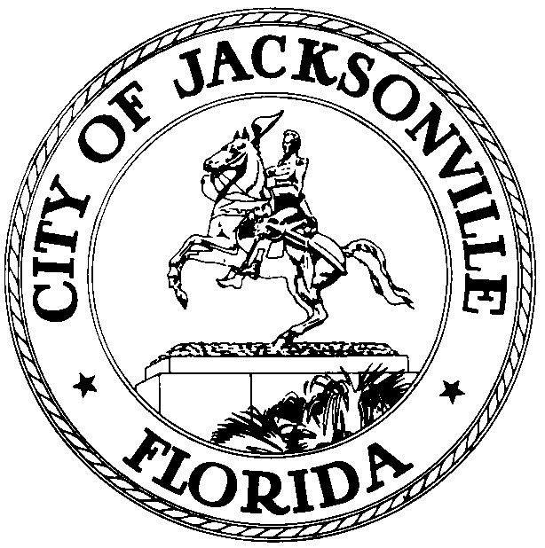
Task Force on Consolidated Government
Council Member Lori Boyer, Chair
Governance & Mission Committee

Issues NOT Discussed
- Form of Government
  - City Council
- Are 19 too many (Mallot), too few (public input), or about right (former Mayors)?
- Should we extend the term of Council President? Change when they take office?
- Should Council members receive more compensation to allow them to devote full time to Council duties?
  - Mayor
- Do any specific responsibilities of Mayor require further elaboration?
- Review the specific language of the charter that discusses the role and responsibilities of the mayor and determine if they need amending.

- Independent Authorities (JEA, JTA, JPA, and JAA)
- Are numbers and selection processes for Board members adequate to insure Board members are accountable to the public and to City government for their decisions?
- How do development activities, or ancillary business enterprise activities, of the Authorities impact City tax rolls and private business opportunities? Should they be restricted in any way? Require some City approval?
- Charter
i. How can the enforcement of existing ordinances be increased? Currently, there are many ordinances that are on the books but are not complied with (i.e. the Neighborhood Bill of Rights, portions of the CIP process, and other situations)
ii. Should the number of votes it takes to waive an ordinance and to waive the charter be changed?

ALL Committee Issues
(Issues NOT Discussed in Bold)
- Form of Government
  - City Council
- Are 19 too many (Mallot), too few (public input), or about right (former Mayors)?
- Would staggered terms add continuity?
- Would off-year fall elections add experience before budget?
- Are At- large seats desirable? What about impact on growing district populations? What about argument that they have a negative impact on racial and diversity mix of Council?
- Should term limits be extended to 12 years or 3 terms? Or 6 year terms?
- Do at-large seats have a negative impact on racial and diversity mix of Council?
- Should we extend the term of Council President? Change when they take office?
- Should Council members receive more compensation to allow them to devote full time to Council duties?
  - Mayor
- Is strong Mayor form still the best model for management of City? Best for leadership?
- Do any specific responsibilities of Mayor require further elaboration?
- Is Mayoral power broad enough? Too broad?
- Does each mayor establish a new mission or should there be a mission beyond administrations? How would that be achieved?
- Review the specific language of the charter that discusses the role and responsibilities of the mayor and determine if they need amending.
  - City Manager
- We have heard about increasing use of professional managers to provide continuity and improve operational management. Would that be desirable in addition to or in place of some current structure?
- How would a manager be chosen? Retention?
- Is this really the CAO? But there are no qualifications for that position and it is not in Charter- purely discretionary appointment not subject to Council approval.
- Should there be a written job description in the Charter describing the role of the CAO and should it be called city manager? If there is a job description, what are the minimum qualifications?

- Office of General Counsel
- Is current selection process viable or is Charter amendment needed? (Is the selection committee only for the Mayor’s benefit and can or should it be waived? Does it serve a purpose? Can an appointment be made prior to the commencement of the Mayoral and Council term for which it is sought?)
- Is charter/code clear as to role, independence, and duty of General Counsel?
- Does current structure, including pension accrual, create conflicts and potential bias? Would term limits, pension ineligibility, or other structural changes be desirable?
- Are changes in removal process desirable to maintain confidence? (Should a supermajority of Council have the right to initiate?)
- What remedies are available to members of any branch who disagree with a decision of the general Counsel? Does this process need to be clarified in the Charter/code?
- How are prior binding opinions implemented or incorporated into the knowledge base for future actions?
- Does the OGC have a responsibility to bring to the attention of the Mayor, Council, Authorities and/or staff Charter and Code provisions governing or relevant to proposed legislation or actions? (for example, portions of Code regarding CIP process that have been ignored, should OGC advise that action would violate Code?)
- How are un-codified ordinances enforced and knowledge of them transmitted? (for example, Neighborhood Bill of Rights)
- Recognizing that currently only the Mayor can initiate a termination proceeding and thereby at least enhancing the perception that the general Counsel is more influenced by the Mayor, should there be alternate means by which the termination of a General Counsel may come about?

- Independent Authorities (JEA, JTA, JPA, and JAA)
- Are numbers and selection processes for Board members adequate to insure Board members are accountable to the public and to City government for their decisions?
- Are the missions of each authority clearly defined and how are they integrated with the greater mission of the City? Independence was viewed as desirable because they were performing a business enterprise activity. Quality and efficiency of operation are certainly valid goals, but how do the goals of facilitating economic growth, providing essential services to citizens, etc. become part of the operational mission?
- How do development activities, or ancillary business enterprise activities, of the Authorities impact City tax rolls and private business opportunities? Should they be restricted in any way? Require some City approval?
- Does the City budget review process provide any real management control with respect to the authorities?
- How do we ensure the independent authorities board members are accountable to both the City and the authority on which they serve?
- Include agencies such as the Children’s Commission and the DIA.
- Should JEA be split into two authorities, one for electric utility and the other for sewer and water?

- Police and Fire Pension Board
- Possibly review the report made by the Pension Review Task Force and issue recommendation on it, but not take up whole issue of pension reform.

- Interlocal Agreements with Beaches/Baldwin
i. How to codify, increase awareness throughout government, improve communication and knowledge of the terms of the agreements

- Charter
i. How can the enforcement of existing ordinances be increased? Currently, there are many ordinances that are on the books but are not complied with (i.e. the Neighborhood Bill of Rights, portions of the CIP process, and other situations)
ii. Should the number of votes it takes to waive an ordinance and to waive the charter be changed?

