 | 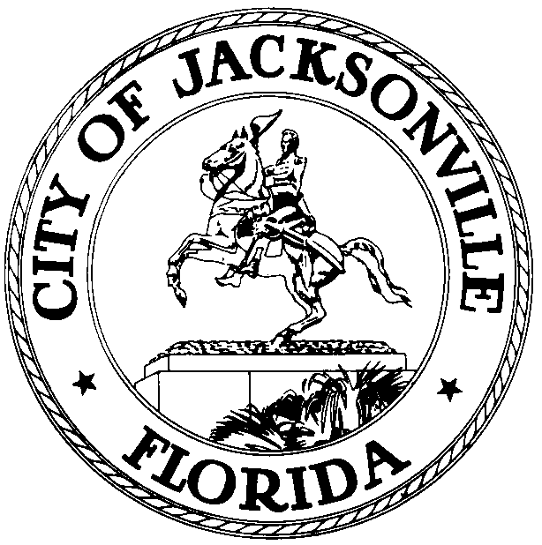
 | OFFICE OF THE CITY COUNCIL
CLAY YARBOROUGH |  | SUITE 425, CITY HALL
COUNCIL MEMBER, DISTRICT 1 |  | 117 WEST DUVAL STREET
OFFICE (904) 630-1389 |  | JACKSONVILLE, FLORIDA 32202
FAX (904) 630-2906 |  | E-MAIL: CLAY@COJ.NET

November 15, 2013
(5:00 PM)

NOTICE

TO: Honorable Bill Bishop
Honorable Johnny Gaffney
Honorable Warren Jones
Honorable Stephen Joost
Honorable E. Denise Lee
Honorable Richard Clark

FROM: Clay Yarborough, Chair
Special Reorganization Review Committee

RE: Special Reorganization Review Committee (2013-209)

Notice is hereby given that the Special Reorganization Review Committee Chair Clay Yarborough is hereby calling a Special Reorganization Review Committee Meeting to discuss, review, examine and make recommendation(s) to Council committees and the full Council as it relates to reorganization of City departments and divisions on Monday, November 25, 2013 at 4:00 PM, Council Chambers, 1st Floor, 117 West Duval Street, Jacksonville, Florida, 32202.

2013-209 ORD-MC Amend Var Chapts & Secs of Ord Code by Reorganizing & Renaming var Depts & Divisions, including Chapt 28 (Parks & Rec), Chapt 30 (Planning & Dev Dept), Chapt 32 (Public Works Dept), Chapt 35 (Neighborhoods Dept), Chapt 55 (Economic Dev), Chapt 23 (Intra-Govt'l Svcs Dept), by moving Divisions to other Depts or Consolidating Divisions; Provide Effective Date of 10/1/13. (Sidman) (Req of Mayor)

Please mark your calendars accordingly. All interested parties are invited to attend.

Please contact Marilyn Allen, Legislative Assistant, at (904) 630-1404 for additional information or correspondence.

CY/ma

cc: Council Members/Staff
Cheryl L. Brown, Director/Council Secretary
Dana Farris, Chief – Legislative Services Division
Carol Owens, Assistant Chief – Legislative Services Division
Jeff Clements, Chief, Research Division
Kristi Sikes, Chief, Administrative Services Division
Office of General Counsel
CITYC@COJ.NET
Electronic Notice Kiosk – 1st Floor City Hall
Public Notice System – City Council Web Page
Media Box

