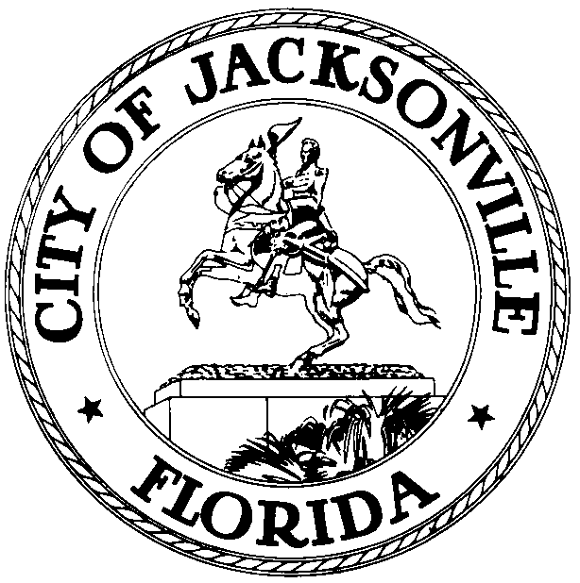

OFFICE OF THE CITY COUNCIL

CHERYL L. BROWN 117 WEST DUVAL STREET, SUITE 425
DIRECTOR 4TH FLOOR, CITY HALL
OFFICE (904) 630-1452 JACKSONVILLE, FLORIDA 32202
FAX (904) 630-2906
E-MAIL: CLBROWN@coj.net

TASK FORCE ON CONSOLIDATION
TOWN HALL MEETING MINUTES

October 28, 2013
6:00 p.m.

FSCJ Kent Campus Auditorium
3939 Roosevelt Boulevard

Attendance: Kay Ehas (Acting Chair), Giselle Carson, Ben Davis, Tony Hill, Opio Sokoni

Also: Jeff Clements – Council Research Division; Steve Cassada - Council Staff Services

Chairwoman Ehas called the meeting to order at 6:06 p.m. and the Task Force members introduced themselves. Ms. Ehas read a statement giving a brief overview of the appointment and work of the Task Force and inviting public input.

Carmen Godwin (Riverside/Avondale Preservation) said that infrastructure in the older core urban area is being poorly maintained. She asked what the Task Force hopes to achieve and how it expects to be able to implement change. She stated that Riverside and Avondale are able to have more of a say over how City policies are implemented in their neighborhoods than many other parts of the city because RAP is well organized and persistent in making its feelings known. Neighborhoods that aren’t so well or organized or persistent have little chance of getting the City apparatus to recognize their interests or desires. Jacksonville is such a large and diverse city that it’s hard to get attention focused on the particular needs of small areas. She suggested that an office or ombudsman who could help citizens and neighborhood organizations deal with the City bureaucracy would be very helpful. She felt the CPACs are too big and too diverse to be able to adequately represent each neighborhood within their boundaries.

Task Force member Tony Hill pointed out that consolidation may not have been good for Jacksonville’s rural areas because the consolidated government’s status as a large city makes it ineligible for U.S. Department of Agriculture grants for infrastructure development, even though we have some very rural areas that would qualify in a county context.

Former City Council member Alberta Hipps stated that she believed the number of council districts is correct and that the most recent redistricting process produced more sensible, compact districts than was the case in previous redistrictings. She said that she has long had a problem with the lack of infrastructure development in the city’s rural areas, and believed that there needs to be continuity at the staff level of City government to ensure that long-term projects continue to move forward as political administrations change. She believes the Comprehensive Plan discourages much development in rural areas, but as the City’s urban areas infill to capacity, new growth is going to have to be accommodated in the less developed outskirts. USDA infrastructure financing assistance would be a great help to areas such as Maxville. Ms. Hipps also stated that resources have been dramatically reduced to the Neighborhoods Department and CPAC staffing in recent years, and the Mayor and department heads don’t attend CPAC meetings on a regular basis as they once did. This seems to indicate a waning of support for the CPACs, which in turn leads to dwindling membership activity as participants see less interest on the part of the City.

Kathy Budd said that she would like to see more participation in CPAC meetings by City Council members; they rarely come to meetings and don’t seem to respond with concrete action to what they hear at the meetings when they do. She stated that CARE complaints to 630-CITY are often marked as “closed” when in fact nothing has been done to remedy the complaint. There needs to be a system, both at the City and at the JEA, of a supervisor making a site visit and confirming that work reported as “completed” has actually been completed and that the work done has adequately solved the problem that was reported. Ms. Budd suggested the possibility of the City designating community spokespersons for various parts of the city to meet on a regular basis with City Council members and departmental officials to organize and coordinate complaints and complaint responses to problems in that area of town. She speculated that participation in CPACs may not be as high as desired because neighborhood representatives tend to have a “single issue” attitude; they’re interested in having their neighborhood’s particular problem addressed, but have little interest in or understanding of the other work of the CPAC (i.e. rezoning and land use changes, long-range planning, etc.). She lamented the need to persistently badger the City to get anything to happen, only to have it be sub-standard and not what the community wanted when something finally happens.

Bryan Gates said that the City is not adequately addressing the decline of the tree canopy in its older areas, only reacting by cutting trees down when an emergency happens. There is no pro-active care of or replanting of new trees. He asked why consolidation was enacted in the 1960s and questioned what the alternatives to consolidation might be. Kay Ehas gave a brief explanation of the pre-consolidation situation in Jacksonville and Duval County with its multi-faceted and overlapping governmental entities and its political corruption.

There being no further business, the meeting was adjourned at 6:46.

Jeff Clements, Council Research Division (904) 630-1404

Posted 10.29.13 4:00 p.m.

