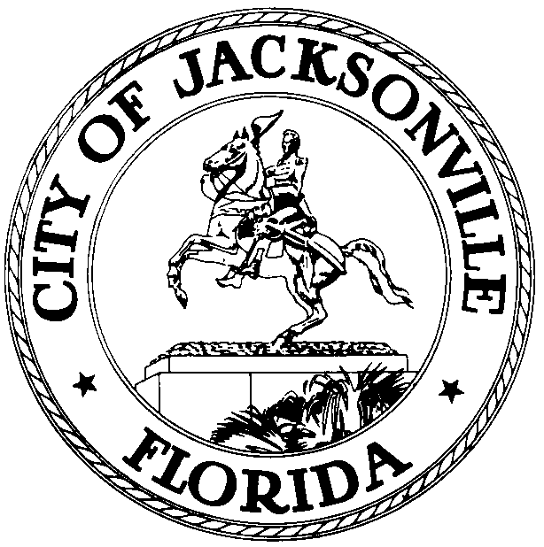
OFFICE OF THE CITY COUNCIL
WILLIAM BISHOP, AIA  PAST PRESIDENT 2012-2013  COUNCIL MEMBER, DISTRICT 2  OFFICE (904) 630-1392  FAX (904) 630-2906  E-MAIL: wbishop@coj.net |  | 117 West Duval Street  SUITE 425  JACKSONVILLE, FLORIDA  32202
August 14, 2013
4:50 p.m.

Meeting Notice

Notice is hereby given that Council Member Bill Bishop and Council Member Greg Anderson, will meet on Tuesday, August 27, 2013, at 11:00 a.m., in Conference Room A, City Council Offices, 117 West Duval Street, Suite 425, City Hall at St. James Building, to discuss the city budget.

All interested parties are encouraged to attend.

Please contact Suzanne Warren, ECA, District 2, for additional information at 630-1392.

cc: Council Members & Staff
Cheryl Brown, Director/Council Secretary
Dana Farris, Chief, Legislative Services Division
Jeff Clements, Chief, Research Division
Office of the General Counsel
Cityc@coj.net
Posted Notice Board - 1st Floor City Hall
Posted Meeting - City Council Calendar
Electronic Notification - 1st Floor City Hall
Posting to Public Notices - City Council Web Page
Media Box

