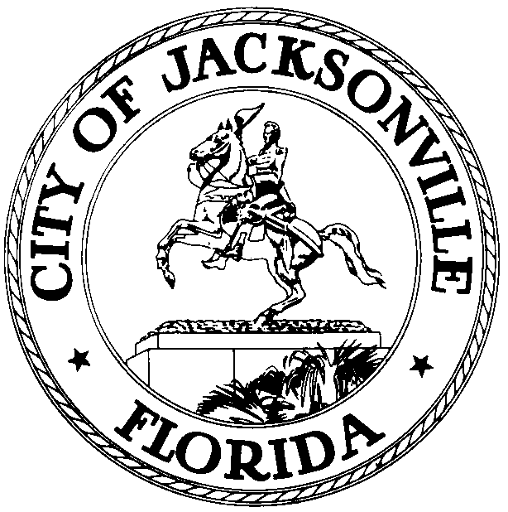

Jacksonville Waterways Commission
Jim Love, Chair

JACKSONVILLE WATERWAYS COMMISSION
Wednesday, January 9, 2013
City Council Chamber
9:30 a.m.

The monthly meeting of the Jacksonville Waterways Commission was called to order at 9:34 a.m. on Wednesday, January 9, 2013, in the City Council Chamber by the Chair, Council Member Jim Love.

In attendance: Council Members Jim Love (Chair), Lori Boyer (Vice Chair), John Crescimbeni; Commissioners Gary L. Anderson, Lane T. Burnett, Edward J. Fleming, Jr., John Godfrey, Ralph C. Hodges, Raymond S. Pringle, Jr., Scott Shine, Stephen Swann, Penny Thompson; State Representative Lake Ray was excused; Assistant General Counsel Paige Johnston; Dr. Quinton White, Dr. Gerard Pinto, Jacksonville University; Captain Jim Suber, Waterways Coordinator; Dave Roman, Mayor’s Office; Vince Seibold, Chief, Environmental Quality Division, Neighborhoods Department; James Richardson, Environmental Protection Board; Captain Mike Getchell, Jacksonville Marine Transportation Exchange; Tera Meeks, Chief, Waterfront Management Programming; Gary Kresel, Jody McDaniel, Planning & Development Department; Geoff Sample, St. Johns River Water Management District; Attorney Tom Ingram; Captain Vic Tison, Captain Roger Bump, Craig Van Brocklin, John Nooney, Recreational Fishing Alliance; Lieutenant Commander Robert Butts, United States Coast Guard; Bill Parker; Bobby Taylor, North CPAC; Marilyn Allen, Legislative Assistant; John J. Jackson, City Council Research Division.

The Commission voted to approve the minutes for the December 12, 2012 Commission meeting.

In Legislation, the Commission considered

2013-13 - ORD Approp $287,000 Grant Funds from St Johns River Water Mgmt Dist (SJRWMD) for the Lincoln Villas Septic Tank Phase-Out Proj for City's Partnership with SJRWMD on Water Quality Proj; Auth Funds Carryover to Subsequent FY's; Auth 3rd Amend to Contract #24903 with SJRWMD for Tributary Water Quality Restoration, Lower St Johns River Basin; Amend Ord 2012-434-E (CIP) to increase Funding for "Lincoln Villas Svcs Area Sewer Imp" and "Septic Tank Phase Out Facilities Plan". (BT 13-019) (McCain) (Req of Mayor)

Vince Seibold, Chief, Environmental Quality Division, Neighborhoods Department, explained the components of the proposed legislation and fielded questions. He explained that this ordinance appropriated additional funding for a project whose overall objective was the restoration of water quality in the Lower St. Johns River Basin. Specifically, this funding was a component of the project that phases out septic tanks within the Lincoln Villas area of Jacksonville. Tributaries of the St. Johns River, such as the Trout River, have been identified as impaired for fecal coliform bacteria. In an answer to a question raised by Commissioner Lane Burnett, residents would not be charged for going on line with JEA once their septic tanks have been eliminated.

The Commission voted 10-0 to recommend approval of the ordinance.

The Commission heard a presentation on Florida Sunshine Laws from Carla Miller, the City’s Ethics Officer and Jason Gabriel, Office of General Counsel. Ms. Miller underscored the importance of adhering to ethical laws and standards as members of a Commission. She implored Commissioners not to hesitate to call her or Jason Gabriel if ever they had questions on the propriety of procedures or actions. Mr. Gabriel’s PowerPoint presentation highlighted Florida Sunshine laws and statutes that focused on open records, public records and public meetings. He explained that Sunshine laws applied not only to elected bodies and officials but to appointed commissions and boards, as well. Florida Statutes mandate that meetings (of legislative bodies, commissions, boards) must be reasonably noticed; meetings have to open to the public; and, minutes of the meeting’s proceedings have to be taken and transcribed.

Next, the Commission heard Dr. Quinton White’s monthly report on the status of the St. Johns River water quality and Dr. Gerard Pinto’s update on manatee activity. Dr. White commented on the great white shark on the First Coast that has been in the news recently. Dr. White reported how a shark tracking group kept abreast of shark movement and that the shark here in the Jacksonville area had been tracked from Cape Cod (Massachusetts). Dr. White indicated that the great whites had followed the right whales’ move southward for calving off the South-Georgia-North Florida coasts. The great whites fed on right whales’ after-birth and on sick or weakly calves.

Dr. White indicated that this has not been a particularly cold winter. The mild weather has resulted in the lower number of manatee deaths in the past year. Ordinarily, each winter the State of Florida takes a synoptic sample of the total number of manatees in the state and the count is derived from aerial surveys. Various state agencies collaborate in the aerial survey. The synoptic survey is done in the aftermath of a cold front that leaves the air and water very clear for the visual count. Owing to our not having had any particularly cold weather or fronts, the synoptic survey will not be conducted this year. However, at a recent meeting with the United States Coast Guard Auxiliary, attended by Dr. White, Jody McDaniel and Captain Jim Suber, discussions are underway to ascertain whether the Coast Guard Auxiliary can be of assistance with aerial surveys of manatees. Our own flights are down; the Coast Guard Auxiliary has a flight component.

Dr. Pinto reported that there were two manatee deaths so far this year, both cold stress related. Manatees continue to be a concern at JEA’s water outfall #2 and the Ortega River basin. If the weather is particularly cold, manatees may have to be rescued from these two sites.

In the FIND Subcommittee update, Commissioner Gary Anderson apprised the Commission on the FIND Subcommittee meeting that had been held Monday morning, January 7th that focused on a FIND Prioritized Project List for 2013 that had been provided by Jody McDaniel. Ms. McDaniel indicated that the list represented the Mayor’s priorities for the projects that the Administration hoped to submit applications to FIND for funding. Commissioner Anderson noted that the Subcommittee’s work was one stop in the process that would ultimately result in a priority list that included proposed projects from the Commission. He thanked Ms. McDaniel for all the work that she has done and continues to do in making the process work.

Commissioner Anderson reported that he and the three other Commissioners that comprised the subcommittee, Commissioners Scott Shine, Lane Burnett and Ralph Hodges, went through the priority project list. Council Members Jim Love and Lori Boyer offered their input as did attendees from the public. Tom Ingram shared his views with the subcommittee and John Nooney did, as well. An extensive e-mail from a Mandarin constituent was distributed that entailed concerns regarding the County Dock Boat Ramp recommendation. Mr. Anderson indicated that on numerous proposed projects the issue of costs was raised.

Commissioner Anderson said that the Waterways Commission is expected to weigh in with its assessment of the priorities and to then make recommendations to the City Council. It was the consensus of the subcommittee that Engineering Division officials ought to be at the Waterways Commission meetings to address the cost concerns.

Council Member Lori Boyer wanted to know what were the best numbers on costs to use: the numbers cited on the Priority List for 2013 or the numbers in the spread sheets that Jody McDaniel had distributed at the meeting. Ms. McDaniel explained that there had been a January 4th meeting with the City’s engineering staff to address the design costs. She indicated that the estimated costs would not be available until January 22nd.

Commissioner John Godfrey asked if the high estimates drive the bids higher.

Council Member John Crescimbeni thanked the Subcommittee for its work. He reminded the Commission that the City Council can add or subtract projects that are on the Administration’s priority list. Mr. Crescimbeni suggested that the Commission put off making any of its own recommendations on priorities until after the January costs estimates are in. He suggested that a special meeting be called where each Commissioner can weigh in with their respective priority list. He suggested that the meeting be held in (City Council) Conference Room A because it is more conducive to mulling over points of view.

Commissioner Raymond Pringle said that he would like to have an explanation of the votes that were taken (recorded and announced) in the Subcommittee on the respective projects. He indicated that he had no idea as to why one project was 0-4, another 4-0, and still others 2-2.

Commissioner Scott Shine was disappointed to see that the City’s master plan for boat ramps was not on the project priority list. Mr. Scott said that it was his understanding that FIND could provide a grant for such a master plan as a project provided that it was a 50/50 funding match with the City.

Council Member Lori Boyer wanted the project priority list amended to add the Riverside Arts Market project that Tom Ingram had suggested; she wanted the Harborview dredge project added, as well.

It was decided that the special meeting of the Commission that will enable individual Commissioners to rank priority projects would be held Monday, January 28th, 9:30 a.m. in Conference Room A.

In Old Business, Commissioner Shine provided the Commission with an update on the initiative to re-open shellfish beds. He indicated that a private concern is needed to do the required water testing. Vince Seibold, Chief of Environmental Quality, is assisting Mr. Shine with this project. Once information on whether or not the water testing can be undertaken gets back to Mr. Seibold, a meeting will be scheduled to decide whether re-opening shellfish beds for harvesting is feasible.

In Comments from the public, Keith Keller, a professional paddle boat operator, addressed the Commission. He represents Access St. Johns River and works with Tom Ingram. Mr. Keller contends that paddlers do not have the access to the river that they deserve; paddlers encounter considerable obstacles to access opportunities to the river, particularly downtown.

Craig Van Brockin raised issues concerning Sisters Creek. In commenting on the Alimacani Taxi project, it was his contention that it was a huge waste of public funds. The money would be better spent for additional parking in the area.

Bobby Taylor, representing the North CPAC, commented on the Half Moon Island project; he is supportive of the project because it provides additional access to the river. He felt that the Alimacani Taxi project needed to be separated from the Huguenot Master Plan. Mr. Taylor was not supportive of the Harborview dredge project.

Attorney Tom Ingram urged the Commission to consider the Northbank Riverwalk Bridge project. He felt that Geffen Park was ideal for a kayak launch. He felt that a pier at Stockton Park would be popular. Mr. Ingram was cool toward the need for a boating master plan.

John Nooney thanked the Commission for agreeing to add the floating dock project at the Shipyard site for consideration. He took issue with the waiver of Ordinance 2012-728 that was open for public hearing at the previous night’s City Council meeting because the waiver allowed the Mandarin Museum & Historical Society, Inc. to operate the Webb Farmhouse, museum building and barn located at 11964 Mandarin Road without a competitive bid. Lastly, Mr. Nooney thought that the names of the individuals and organizations who recommended projects for the priority list of FIND projects should be attached.

There being no further business, the meeting was adjourned at 11:52 a.m.

John J. Jackson, Council Research Division (904) 630-1729

01.17.13
Posted: 12:00 P.M.

