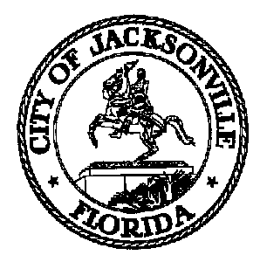

OFFICE OF THE CITY COUNCIL

Lori N. Boyer, Council Member 117 W. Duval Street, Suite 425
District 5 4th Floor, City Hall – St. James Bldg.
Phone (904) 630-1382 Jacksonville, Florida 32202
Fax (904) 630-2906
E-Mail: LBOYER@coj.net

TASK FORCE ON CONSOLIDATED GOVERNMENT

Meeting Notice

September 6, 2013
5:00 p.m.

TO: Consolidated Government Task Force Members

Chuck Arnold Dr. Georgette Dumont Steve Rohan
Cynthia B. Austin Kay Ehas Peter Rummell
Shannon Blankinship Broderick Green Dwain Senterfitt
Elaine Brown Tony Hill Opio Sokoni
Betty S. Burney Betty Holzendorf Kerry Stewart
Leon J. Carrero Jordan Logue Tom Taylor
Rena Coughlin Bill Mason Raymond Treadwell
Lad Daniels Sam Mousa Paul Tutwiler
Ben Davis Michael Munz Dr. Kelli Wells
Wyman Duggan Jim Rinaman Rev. Dr. Marvin Zanders
Giselle Carson- Alternate
Paul Dillard- Alternate

FROM: Council Member Lori Boyer, Chair

SUBJECT: Task Force on Consolidated Government Meeting Notice 9.12.13

Notice is hereby given that the Task Force on Consolidated Government Chair, Council Member Lori Boyer will meet with the Task Force Members in the Council Chamber located at 117 W. Duval St., 1st Floor, City Hall - St. James Building on Thursday, September 12, 2013 at 9:00 A.M. Notification of additional meetings will follow when scheduled. Please mark your calendars accordingly.

When attending Task Force meetings, members are to park in the parking garage located on the corner of Main and Duval Street (Library Garage) to receive free parking. Please see Cheryl Brown at each meeting for parking validation.

cc: Cheryl Brown, Council Director
Dana Farris, Chief of Legislative Services
Jeff Clements, Chief of Research
Rachel Welsh, System Information Administrator
Damian Cook, Task Force Staff Support
File
cityc@coj.net

/tmp/in/input.doc

