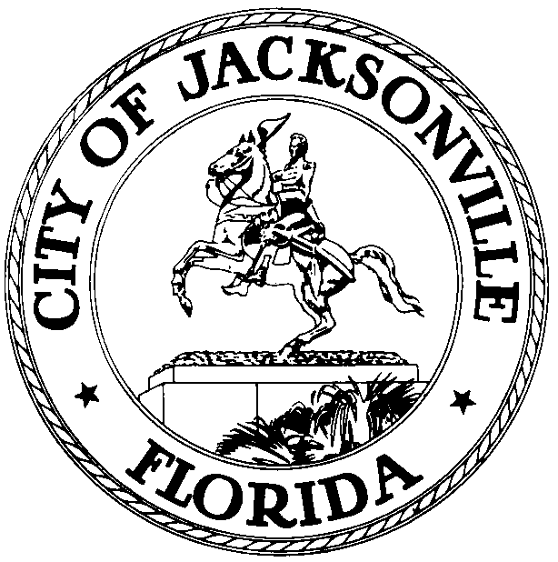

Jacksonville Waterways Commission
Jim Love, Chair

JACKSONVILLE WATERWAYS COMMISSION
Wednesday, December 12, 2012
City Council Chamber
9:30 a.m.

The monthly meeting of the Jacksonville Waterways Commission was called to order at 9:34 a.m., Wednesday, December 12, 2012, in the City Council Chamber, by the Chair, Council Member Jim Love.

In attendance: Council Members Jim Love (Chairman), Lori Boyer (Vice Chair) and John Crescimbeni; Commissioners Gary L. Anderson, Lane T. Burnett, Edward J. Fleming, Jr., John Godfrey, Ralph C. Hodges, Scott Shine, Stephen Swann, Penny Thompson; Commissioner Ray S. Pringle, Jr. and State Representative Lake Ray were excused; Assistant General Counsel Paige Johnston; Dr. Quinton White, Dr. Gerard Pinto, Jacksonville University; Captain Jim Suber, Waterways Coordinator/Harbor Master; Legislative Assistant Marilyn Allen; Dave Roman, Mayor’s Office; Tera Meeks, Chief, Waterfront Management Planning; Geoff Sample, St. Johns River Water Management District; James Richardson, Environmental Protection Board; Vince Seibold, Chief, Environmental Quality Division; Attorney Tom Ingram; Rob Littlepage, Florida Times-Union; Kevin Kuzel, Executive Council Assistant (Love); John Nooney, Craig Van Brocklin, Recreational Fishing Alliance; Captain Bill Parker; John J. Jackson, Council Research Division.

The Commission voted to approve the minutes for the November 14, 2012 meeting.

Rick Carper, Director, Atlantic Beach Public Works Department, made a PowerPoint presentation on the City of Atlantic Beach’s Intracoastal Waterways Preserves Master Plan.
The ICW Preserves encompasses Tideviews – 8 acres – acquired in 1994; Dutton Island 40 acres – acquired in 1998 as a joint Atlantic Beach-City of Jacksonville project; River Branch – 362 acres – acquired 2009-2012. Mr. Carper described the goal of the study was to develop a plan that: promotes environmental conservation, management and education; increases public access and awareness by providing passive/resource-based recreation opportunities; that enhances connectivity to the Intracoastal Waterway Preserves from surrounding land uses and other public lands through such methods as way finding signage, walkways/trails and viewing areas. The Master Plan study process began in June 2011. Atlantic Beach is expected to apply for FIND grants for the design, permitting and construction phases of the development plan’s projects.

Mark Crosley, Assistant Executive Director, Florida Inland Navigation District (FIND), provided the Commission with an update on FIND operations and outlook. He gave the Commission an overview of FIND’s primary mission that focuses on funding projects that provide the public with access to waterways. Mr. Crosely explained the two-pronged application for FIND funding: Phase I funds design and permitting and, Phase II, construction. In the grant match formula for FIND funding, a City or County’s match provided for Phase I cannot reimbursed if a construction contract has not been issued within a year after the applicant has closed out the grant.

Commissioner Aaron Bowman, who represents Duval County on the Florida Inland Navigation District, made brief remarks on FIND’s mission and work.

Council Member John Crescimbeni, a former Chairman of the Jacksonville Waterways Commission, explained the formula of ad valorem taxes that are collected from the County, 80% of which is available for grants in return. He also explained the application process for grants and how FIND evaluates, scores and ranks proposed projects.

Mr. Crosley commended Jacksonville’s vetting process for the applications that the County submits to FIND.

Commissioner Gary Anderson provided the Commission with an update on the FIND Subcommittee that met on November 26, 2012. He explained why the Alimacani Taxi Dock project was withdrawn from the FIND prioritized project list for 2013 and why San Marco Lake, Charles Reese Boat Ramp and Half Moon Island were placed “below the line” on the list. Council Member John Crescimbeni asked Attorney Tim Ingram for his response to the projects on the FIND prioritized project list. (Mr. Ingram is an advocate for kayaking and other non-motorized waterways craft). Mr. Crescimbeni noted that Mr. Ingram had presented an array of projects last year and that none of those projects were on the list that the Administration put together for this year’s grant applications.

Council Member Crescimbeni disputed how the Blue Cypress Boardwalk extension project had been depicted by the Administration and requested Assistant General Counsel Paige Johnston to review the lease, legislation and amendments that the City Council enacted when the Council leased space to the Jacksonville Sheriff’s Office for its watercraft at the Blue Cypress site.

Commissioner Ralph Hodges noted that the Charles Reese Boat Ramp was “below the line” on the FIND Prioritized Project List; he felt that the project should be higher on the list.

The Ortega River Mooring Field status was discussed, with Waterways Coordinator, Captain Jim Suber, and Waterfront Management Planning Chief explaining and fielding questions.

Council Member Lori Boyer wanted to know if there were other attendees at the Subcommittee meeting putting forth or suggesting any projects. The Council Member believes that more people ought to be aware of the meetings; she particularly felt the need to have parties that understood and could talk about the costs of projects attend the meetings.

Council Member John Crescimbeni echoed Council Member Boyer’s position that more citizens need to be aware of and attend FIND Subcommittee meetings.

Mike Hollingsworth, U.S. Army Corps of Engineers, made a presentation and fielded questions on the Corps’ recently announced decision to undertake a barrier project whose objective is to prevent a high level of salinity from going upstream when the St. Johns River is deepened. The St. Johns River is being deepened to accommodate post-Panamax ships.

In his monthly update on the St. Johns River Status and Water Quality update, Dr. Quinton White reported that the salinity in the river was up; the temperature was averaging 68∘. We experienced a wet (rainy) spring and summer and a dry fall. The current rainfall is normal.

Dr. White was doubtful that the Army Corps of Engineers’ barrier project would work.
He announced that the Georgia-Pacific discharge into the St. Johns River is now underway and that the process is being monitored. Dr. White mentioned the news article in the morning’s Florida Times-Union regarding the slips and marina proposed for Black Creek (in Green Cove Springs). He felt that we had to wait and see what the federal and state officials do in the permitting process. Dr. White reported that as the temperature in the St. Johns River drops, the numbers of manatees and dolphins in the river diminish.

Dr. Gerard Pinto reported that there had been three manatee fatalities since the last Waterways Commission meeting. One of the fatalities, near Fort Caroline, was the result of collision with a large vessel. There has been a total of 12 deaths reported for the year – 5 from watercraft collision; 4 from cold stress; 1 perinatal; 2 unknown causes.

The St. Johns Riverkeeper, Lisa Rinaman, commented on the November 3, 2012 federal government’s ruling on nutrients in the river. She felt that the nutrient ruling was good news for Duval County and for the health of the St. Johns River and its tributaries. She advised the Commission of a public meeting of the Environmental Protection Administration that will be held in Tampa in January 2013. The Riverkeeper reported that the St. Johns Water Management District voted to retain 92% or the 600,000 acres that it had reviewed for possible sale.

In Comments from the Public, Captain Bill Parker, representing the In River Ocean Foundation, expressed the hope that the Commission would recommend that one of the proposed in-shore artificial reefs be named in memory of Clay Roberts, a Bishop Kenny student and avid fisherman who had been killed.

Craig Van Brocklin, Recreational Fishing Alliance, spoke of problems that kayakers had encountered at Castaway Island. He was also concerned that too often, people who would be interested in issues that the Commission addressed were unaware of the meetings. In response, Council Member John Crescimbeni suggested that the public comment cards that meeting attendees are required to fill-out should have a space for e-mail addresses that would enable them to be put on a mailing list for meeting notices.

John Nooney commented on the FIND Prioritized Projects List; he would like to see the Shipyards put on the list as a project. Mr. Nooney indicated that he has been assured by FIND that that body would be supportive of pocket-pier parks if the proposed project had a (City Council) sponsor. Mr. Nooney also announced an additional ($10.00) donation to the artificial reef program.

There being no further business, the Waterways Commission meeting was adjourned at 12:36 P.M.

John J. Jackson, Council Research Division (904) 630-1729

01.07.13
Posted: 4:00 P.M.

