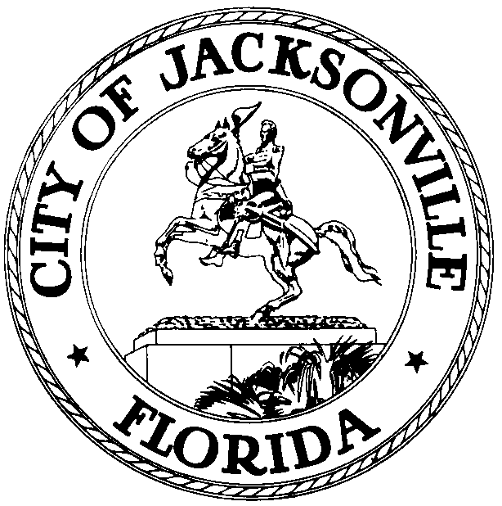

OFFICE OF THE CITY COUNCIL

GREG ANDERSON  COUNCIL MEMBER  AT-LARGE, GROUP FOUR  OFFICE (904) 630-1398  FAX (904) 630-2906 |  | SUITE 425, CITY HALL  117 WEST DUVAL STREET  JACKSONVILLE, FLORIDA 32202  E-MAIL: GANDERSON@coj.net

November 9, 2012
2:30 P.M.

M E M O R A N D U M

TO: The Honorable John Crescimbeni
The Honorable E. Denise Lee
Special Committee Members

FROM: The Honorable Greg Anderson, Chair
Courthouse Oversight Special Committee

SUBJECT: Courthouse Oversight Special Committee Meeting 11-15-12

Notice is hereby given that the Honorable Greg Anderson, Chair of the Courthouse Oversight Special Committee, is calling a Courthouse Oversight Committee Meeting and will meet with the Committee members on Thursday, November 15, 2012 at 2:00 P.M. in Conference Room A, 4th Floor of City Hall, 117 W. Duval St, Jacksonville, Florida for an update on the Courthouse construction.

All interested parties are invited to attend. Please mark your calendars accordingly.

Please contact Philip Zamarron, Legislative Assistant, at (904) 630-1404 for additional information or correspondence.

GA/prz

cc: Council Members/Staff
Cheryl L. Brown, Director/Council Secretary
Dana Farris, Chief, Legislative Services Division
Carol Owens, Asst Chief, Legislative Services Division
Jeff Clements, Chief, Research Division
Kristi Sikes, Chief, Administrative Services Division
CITYC@COJ.NET
Posted Notice Board – 1st Floor City Hall
Electronic Notice Kiosk – 1st Floor City Hall
Public Notice System – City Council Web Page
Media Box
File Copy

