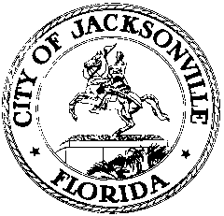

OFFICE OF THE CITY COUNCIL

LORI N. BOYER  COUNCIL MEMBER  DISTRICT 5  OFFICE (904) 630-1382  FAX (904) 630-2906 |  | SUITE 425, CITY HALL  117 WEST DUVAL STREET  JACKSONVILLE, FLORIDA 32202  E-MAIL: LBOYER@coj.net

October 5th, 2012
3:30 p.m.

TWICE AMENDED

MEETING NOTICE

Council Member Lori N. Boyer will be meeting with Council Member Denise Lee, to discuss the CIP adoption and amendment process. This meeting is open to all Council Members who are interested in this topic. The meeting will take place on Tuesday, October 9th, 2012, at 10:30 a.m., in Conference Room B, Suite 425, City Hall, 117 West Duval Street, Jacksonville, Florida 32202.

All interested parties are invited to attend.

Please contact James Nealis, Council Aide, at (904) 630-7360 for additional information or correspondence.

LNB/jn

cc: Council Members/Staff
Cheryl L. Brown, Director/Council Secretary
Dana Farris, Chief – Legislative Services Division
Carol Owens, Assistant Chief – Legislative Services Division
Jeff Clements, Chief, Research Division
Kristi Sikes, Chief, Administrative Services Division
CITYC@COJ.NET
Electronic Notice Kiosk – 1st Floor City Hall
Public Notice System – City Council Web Page
Media Box
File Copy

