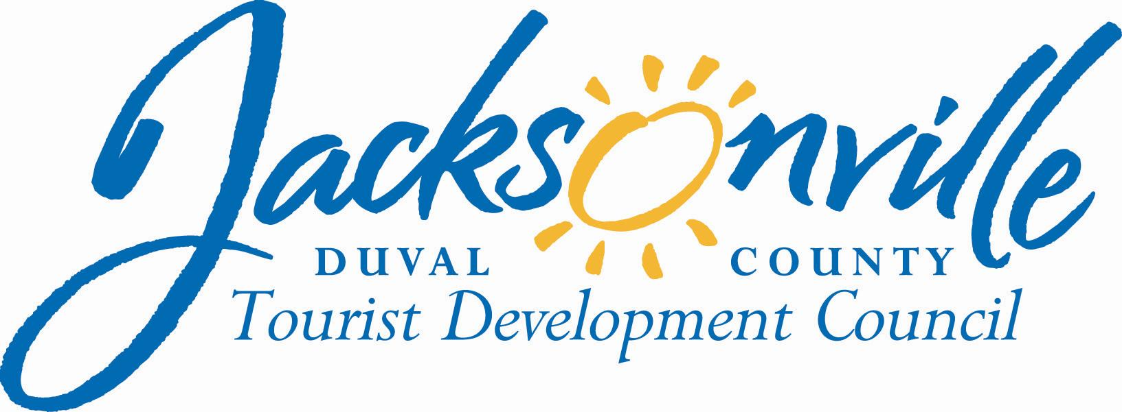
OFFICE OF THE CITY COUNCIL

Annette R. Hastings 117 WEST DUVAL STREET, SUITE 425
TDC EXECUTIVE DIRECTOR 4TH FLOOR, CITY HALL
OFFICE (904) 630-7625 JACKSONVILLE, FLORIDA 32202
FAX (904) 630-2906
E-MAIL: ANNETTEH@coj.net`
September 25. 2012
9:30 p.m.

Duval County Tourist Development Council
Special Meeting Visit Jacksonville Marketing Plan
TDC Minutes
September 20, 2012
Conference Room A, Fourth Floor, Suite 425
City Hall @ St. James

Meeting Convened: 10:00a.m. Meeting Adjourned: 11:15 p.m.

Roll Call:

Council President William Bishop
Council Member Richard Clark
Council Member Warren Jones
Sonny Bhikha-Excused

Henry Fonde
M G Orender
David Potts-Excused
Fred Pozin

Annette R. Hastings, Executive Director
Janice Billy, Assistant Council Auditor
Jim McCain, Asst. General Counsel
Kerri Stewart, Interim President, Visit Jacksonville

Others Present:
Bill Prescott, Vice Chairman, Visit Jacksonville Board; Janice Lowe, Chairman, Visit Jacksonville Board; Kim Ritten, Visit Jacksonville; Kimberly Morgan, Visit Jacksonville; Katie Kurycki, Visit Jacksonville; Patty Jimenez, Visit Jacksonville; Max Marbut, Financial News & Daily Record.

Call to Order:
Chairman, William Bishop, called the meeting to order at 10:00 a.m., noting the presence of a quorum.

Purpose of the Special TDC Meeting:
Chairman Bishop stated that the purpose of this special called TDC meeting was to consider for approval the Visit Jacksonville Marketing Plan for FY 2012-2013, Visit Jacksonville Budget for FY 2012-2013, and Visit Jacksonville Contract for 2012-2013.

Presentation:
Visit Jacksonville Marketing Plan 2012-2013
Presenter: Kerri Stewart /Interim President, Visit Jacksonville
Bill Prescott, Vice Chairman, Visit Jacksonville Board

Visit Jacksonville’s Business Plan 2012-2013
Ms. Kerri Stewart, Interim President of Visit Jacksonville, distributed the Visit Jacksonville’s Business Plan 2012-2013 and Visit Jacksonville Income Statement Budget 2012-2013. Ms. Katie Kurycki, Director of Marketing & Product Development, gave an overview of the Visit Jacksonville Business & Marketing Plan 2012-2013 noting that on the sales side, there will be a new focus on business development and sales. (for details of Business Plan see attached PDF ).

- Visit Jacksonville’s Business & Marketing Plan 2012-2013
  - Welcome, Vision, Organization Overview
  - Proposed Organization & Historical Information
  - Destination Overview
  - Promotion & Expansion of Convention Activities
  - Marketing of Tourist-Orient Facilities and Attractions
  - Partner Development
  - Resources

Discussion:
- Mr. Fred Pozin asked about the budget and if additional dollars had been added for advertising and marketing this year over last year’s dollars? Ms. Stewart stated that it was split 60% for sales and 40% for marketing which was an increase in both areas.
- Mr. Pozin expressed concerns that the budget was heavy on salaries and not enough for pure advertising.
- Mr. Fonde asked for clarification regarding the focus on convention sales.
- Mr. Orender asked for confirmation that multicultural marketing was included in the Visit Jacksonville Business and Marketing Plan.
- Mr. Pozin asked about increase in administration costs. Mr. Prescott noted the increase in administrative cost was to hire the new Visit Jacksonville CEO/President.
- Chairman Bishop appointed a subcommittee and charged Councilman Clark and Mr. Orender to look into other TDC structures and ways of doing business. The subcommittee will bring back a report of their findings to the TDC at the next scheduled TDC quarterly meeting to be held on November 16, 2012.
- There being no further discussion a motion was made to approve the Visit Jacksonville Business and Marketing Plan FY 2012-2013 as presented.

TDC Action:
A motion was made and seconded to approve the Visit Jacksonville’s Business Plan FY 2012-2013 as presented. Approved 5-1 (Fred Pozin)

Visit Jacksonville Budget 2012-2013
Presenter: Kerri Stewart /Interim President, Visit Jacksonville
Bill Prescott, Vice Chairman, Visit Jacksonville Board

Discussion:
- Councilman Clark proposed giving an additional 10% for marketing.
- Mr. Pozin said he would not give additional 10% for advertising based on the budget submitted…want to see less in administration cost and more in advertising.
- Councilman Clark disagreed.
- Mr. Orender noted he wanted the best person to run the organization. However, the budget presented reflected what was in the Request for Proposal (RFP )and the proposed increase for marketing dollars should be a separate motion.
- Mr. Fonde stated, as one of longest sitting members of the TDC, in past years there was not an automatic marketing addition every year. This funding was started fairly recently due to economic difficulties and was not automatic but has tried to become automatic. Mr. Fonde noted it needed to be kept as a separate item …number one , for TDC leverage… number two, the good possibility that in the near future TDC may want to spend the funds on something that was more important and needed that discretion to make the decision.
- Mr. Jim McCain stated that he had spoken with Mr. Greg Pease, Chief of Procurement, regarding this issue and both were in agreement it would be a material departure from the terms of the RFP and any 10% for advertising should be separate. The RFP was put out at 70% and that would be inviting a protest if increased to 80%.
- Mr. Pozin was in agreement it should not be a fixed amount, and would like to see a new budget.
- Ms. Stewart stated the Visit Jacksonville Board was aware of Mr. Pozin’s concerns but numbers were up over last year with seven less staff members.
- Councilman Jones made a motion to approve the budget as presented and it was seconded by Councilman Clark.

TDC Action:
A motion was made and seconded to approve the Visit Jacksonville Budget FY 2012-2013, per contractual agreement of 70%, in the amount of $3,474,402.00. Approved 5-1(Fred Pozin)

Visit Jacksonville Contract FY 2012-2013:
Jim McCain, Assistant General Counsel, distributed the Visit Jacksonville Contract 2012-2013. It is an agreement between the City of Jacksonville and Visit Jacksonville for Marketing, Advertising, Promotional, and Support Service.

Discussion
- Councilman Clark submitted proposals for amendments to the Visit Jacksonville contract for consideration:
  - Visit Jacksonville Source Provider/Renewal Option
  - Visit Jacksonville Independent Annual Audit
- Mr. Orender proposed an amendment to add trademarks/domain name as property of the TDC.
- Mr. Pozin proposed an amendment that movement of budget dollars would be capped at 10% to move line items without coming back to the TDC for approval per the RFP.
- A motion was made and seconded to approve the proposed amendments to the contract and the contract be accepted with those changes.
- There being no further discussion, a motion was made to amend and approve the Visit Jacksonville Contract with approved 70% contractual amount of $3,474,402.00.

TDC Action:
A motion was made and seconded to amend and approve the Visit Jacksonville Contract FY 2012-2013 in the amount of $3,474,402.00. Approved 6-0.

Adjourned:
There being no further business to discuss, the meeting was adjourned at 11:15a.m.

Minutes: Annette R. Hastings-TDC 09/25/12 “Draft” Copy of Minutes/CityC
Tapes: Audio CD 1-LSD
Materials: Submitted to LSD 09/25/12
TDC Meeting Notice September 20, 2012
Agenda
Sign-in Sheet
E-mail copy: Sonny Bhikha/ excused absence
David Potts/excused absence
Visit Jacksonville’s Business Plan 2012-2013
Visit Jacksonville Income Statement Budget 2012-2013
Visit Jacksonville “Draft” Contract
Memo: Councilman Clark “Marketing Contract” Recommended Changes

