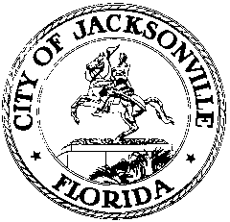

OFFICE OF THE CITY COUNCIL

LORI N. BOYER  COUNCIL MEMBER  DISTRICT 5  OFFICE (904) 630-1382  FAX (904) 630-2906 |  | SUITE 425, CITY HALL  117 WEST DUVAL STREET  JACKSONVILLE, FLORIDA 32202  E-MAIL: LBOYER@coj.net

August 27, 2012
11:00 A.M.

M E M O R A N D U M

TO: The Honorable Greg Anderson
The Honorable Doyle Carter
The Honorable Kimberly Daniels
The Honorable Don Redman

FROM: Council Member Lori Boyer, Chair
Special Committee on Context Sensitive Streets

RE: Special Committee on Context Sensitive Streets Meeting Notice, September 12, 2012

Notice is hereby given that the Honorable Lori Boyer, Chair of the Special Committee on Context Sensitive Streets, will meet with members of the Special Committee on Wednesday, September 12, 2012 at 4:00 P.M. in the Council Chamber, 1st Floor of City Hall, 117 W. Duval St, Jacksonville, Florida.

All interested parties are invited to attend. Please mark your calendars accordingly.

Please contact Philip Zamarron, Legislative Assistant, at (904) 630-1404 for additional information or correspondence.

LB/prz

cc: Council Members/Staff
Cheryl L. Brown, Director/Council Secretary
Dana Farris, Chief, Legislative Services Division
Carol Owens, Asst Chief, Legislative Services Division
Jeff Clements, Chief, Research Division
Kristi Sikes, Chief, Administrative Services Division
CITYC@COJ.NET
Posted Notice Board – 1st Floor City Hall
Electronic Notice Kiosk – 1st Floor City Hall
Public Notice System – City Council Web Page
Media Box
File Copy

