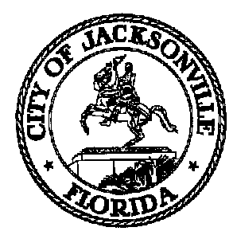
ST. JOHNS RIVER FERRY COMMISSION
John Crescimbeni, Chair
117 W. Duval Street
Suite 425, City Hall
Jacksonville, FL 32202

August 30, 2012
(2:00 p.m.)

NOTICE

TO: St. Johns River Ferry Commission Members
Aaron Bowman
Elaine Brown
Marla Buchanan
Carl Cannon
Richard Redick
Larry Williams

FR: John Crescimbeni, Chair
St. Johns River Ferry Commission

RE: Meeting Notice St. Johns River Ferry Commission 09.04.12
_____________________________________________________________

Notice is hereby given that Council Member John Crescimbeni, Chair of the St. Johns River Ferry Commission, will meet with the Members of the St. Johns River Ferry Commission. The meeting will be held on Tuesday, September 4, 2012 at 5:00 p.m., in Conference Room A, Suite 425, 4th Floor – City Hall, 117 West Duval Street, Jacksonville, Florida, 32202.

Please mark your calendars accordingly. All interested parties are invited to attend.

Please contact Merriane Lahmeur - Legislative Services Division at (904) 630-7633 for additional information or correspondence.

JC/mgl

xc: Council Members/Staff
Cheryl L. Brown, Director/Council Secretary
Dana Farris, Chief – Legislative Services Division
Carol Owens, Assistant Chief – Legislative Services Division
Jeff Clements, Chief, Research Division
Kristi Sikes, Chief, Administrative Services Division
Council Auditor’s Office
Office of General Counsel
CITYC@COJ.NET
Electronic Notice Kiosk – 1st Floor City Hall
Public Notice System – City Council Web Page
Media Box

