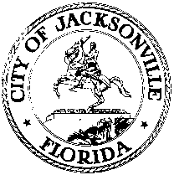

OFFICE OF THE CITY COUNCIL

RAY HOLT 117 WEST DUVAL STREET, SUITE 425
Council Member, District 11 4th FLOOR, CITY HALL
OFFICE (904) 630-1383 JACKSONVILLE, FLORIDA 32202
FAX (904) 630-2906
E-MAIL: Holt@coj.net

February 21, 2012
1:29 P.M.

NOTICE

Notice is hereby given that Council Member Ray Holt will meet with Council Member Jim Love to discuss parking problems in Riverside area specifically the King Street commercial area on Wednesday, February 22nd at 1:30 pm in conference room B, located at 117 West Duval Street, Suite 425 City Hall St. James Building.

All interested persons are invited to attend.

Please contact Connie Holt, ECA-District 11, at (904) 630-1675 for additional information or correspondence.

RH/clh

xc: Council Members/Staff
Cheryl L Brown, Director/Council Secretary
Dana Farris, Chief –Legislative Services
Carol Owens, Assistant Chief – Legislative Services
Jeff Clements, Chief of Research
CITYC@COJ.NET
Office of General Counsel
Electronic Notice Kiosk – 1st Floor City Hall
Public Notice System – City Council Web Page
Media Box
File Copy

