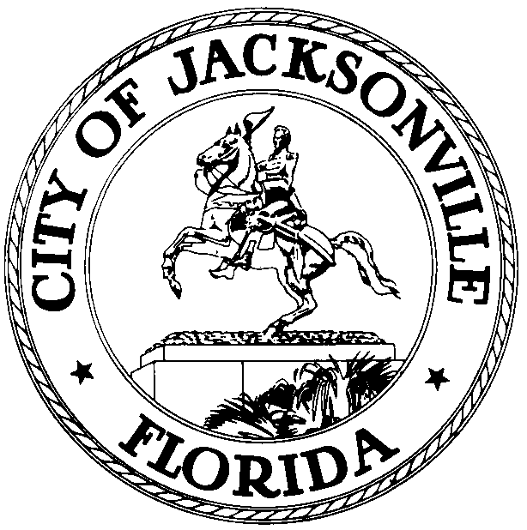

OFFICE OF THE CITY COUNCIL
Ray Holt 117 WEST DUVAL STREET
COUNCILMAN, District 11 SUITE 425
OFFICE (904) 630-1383 JACKSONVILLE, FLORIDA
FAX (904) 630-3403 32202

January 25, 2010
(3:00 pm)

NOTICE

M E M O R A N D U M

TO: Honorable Warren Jones – Member
Honorable Reggie Brown – Member
Honorable Stephen Joost – Member
Honorable Don Redman – Member
Honorable Daniel Davis – Member
Honorable Johnny Gaffney – Member

FR: Honorable Ray Holt, Chairman
Land Use and Zoning Committee

RE: Meeting Notice Special LUZ Workshop 2.2.10
_____________________________________________________________

Notice is hereby given that the Honorable Ray Holt, Chair of the Land Use and Zoning Committee, is hereby scheduling a Special Land Use and Zoning Committee Workshop to discuss pending legislation 2010-37 on Tuesday, February 2, 2010 at 4:30 p.m., in Council Chambers, 1st Floor, 117 West Duval Street, Jacksonville, Florida, 32202.

2010-37 ORD Apv Proposed 2009E Series Semi-Annual Text Amends to Future Land Use Element, Infrastructure Element & Capital Improvemts Element of 2010 Comp Plan (Pending 2030 Comp Plan) re Evaluation & Appraisal Report Recommendations & 2030 Mobility Plan. (Riley) (LUZ), LUZ PH - 2/17/10, Public Hearing Pursuant to Sec 163.3184, F.S. & Chapt 650, Pt 4 Ord Code - 2/9/10 & 2/23/10

Please mark your calendars accordingly. All interested parties are invited to attend.

Please contact Merriane Lahmeur or Jessica Stephens - Legislative Services Division at (904) 630-1404 for additional information or correspondence

RH/mgl

xc: Council Members/Staff
Cheryl L. Brown, Director/Council Secretary
Dana Farris, Chief – Legislative Services Division
Carol Owens, Assistant Chief – Legislative Services Division
Jeff Clements, Chief, Research Division
Kristi Sikes, Chief, Administrative Services Division
Planning and Development Department
Office of General Counsel
CITYC@COJ.NET
Electronic Notice Kiosk – 1st Floor City Hall
Public Notice System – City Council Web Page
Media Box

