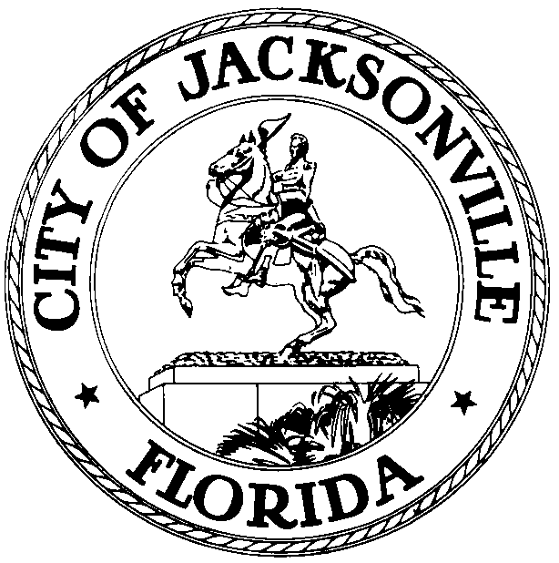

OFFICE OF THE CITY COUNCIL

GLORIOUS J. JOHNSON 117 WEST DUVAL STREET
COUNCIL WOMAN, AT-LARGE 5 SUITE 425
OFFICE (904) 630-1387 JACKSONVILLE, FLORIDA
FAX (904) 630-2906 32202
E-MAIL: gloriousj@coj.net
January 5, 2010
4:30 P.M.

M E E T I N G N O T I C E

Notice is hereby given that Council Member Glorious Johnson and Council Member Jack Webb (Dist.6), and Chad Poppell, Chief of Human Resources, Sherry Hall, Policy Director and Steve Rohan, Deputy General Counsel representative from the Office of General Council will meet on Friday, January 8, 2010 at 11:30 a.m. The meeting will take place in Conference Room B, Suite 425, 4th Floor at the St. James Building, located at 117 W. Duval Street, Jacksonville, Florida 32202 for the purpose of discussing, 2009-549 AMIOS as follow:

2009-549 ORD-MC Amend Chapt 116 (Employees & Employee Benefits), Create new Sec 116.901 (Asst Mgmt Improvement Officers); AMIOs to be Apptd by Mayor & Confirmed by Council; Limit Number to 20; Addressing Qualifications, Job Descriptions, Salary Ranges; Create Reporting Requirement; Protect Existing Employees. (Rohan) (C/M Johnson & Webb)
Public Hearing Pursuant to Chapt 166, F.S. & CR 3.601 - 8/11/09

All interested parties are invited to attend.

Please contact Sandra Lane, Executive Council Assistant, to Council Member Glorious Johnson, At-Large, Group 5, at (904) 630-1387, for additional information or correspondence.

GJJ/sl

CC: Council Members/Staff
Cheryl L Brown, Director
Dana Farris, Chief of Legislative Services
Carol Owens, Assistant Chief of Legislative Services
Jeff Clements, Chief of Research
Office of General Counsel
CityC@coj.net
Posted Notice Board – 1st Floor City Hall
Posted Meeting – City Council Calendar
Electronic Notification – 1st Floor City Hall
Posting to Public Notices – City Council Web Page
Media Box
File Copy

