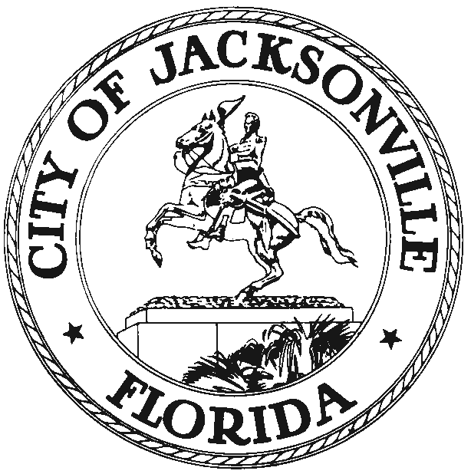

DUVAL COUNTY VALUE ADJUSTMENT BOARD
117 W. Duval Street, Suite 430
Jacksonville, FL 32202
Office (904) 630-7370
Fax (904) 630-0576

AMENDED
November 8, 2010
(3:30 pm)

Notice is hereby given that Jacksonville City Council Member John Crescimbeni, Chair of the City’s 2009 Value Adjustment Board, sets the following meeting dates and times for the monthly meeting. Chairman Crescimbeni will meet with the Value Adjustment Board Members on the third Thursday of each month at 8:30 a.m. in Council Chambers, 1st Floor, City Hall at St. James, 117 West Duval Street, Jacksonville, Florida.

All interested persons are invited to attend.

Please contact any member of the VAB Staff, at (904) 630-7370, for additional information or correspondence.
VALUE ADJUSTMENT BOARD MEETING DATES AND TIMES
Dates Times
1/21/10 9:00 AM
2/18/10 9:00 AM
3/18/10 9:00 AM
4/15/10 9:00 AM
5/20/10 9:00 AM
6/17/10 9:00 AM
8/19/10 9:00 AM
9/16/10 9:00 AM
10/21/10 9:00 AM
11/18/10 9:00 AM
01/20/11 8:30 AM
02/17/11 8:30 AM
JC/clo

cc: Council Members/Staff Media Box
Cheryl Brown, VAB Clerk File Copy
Carol Owens, Assistant VAB Clerk CityC@coj.net
Dana Farris, Chief, Legislative Services Division
Jeff Clements, Chief of Research
Kirk Sherman, Council Auditors Office
William Jeter, Jr., VAB Attorney
Loree French/Mike Wedner, Attorneys for Property Appraiser
Posted Meeting – City Council Calendar
Electronic Notification – 1st Floor City Hall
Posting to Public Notices – City Council Web Page

