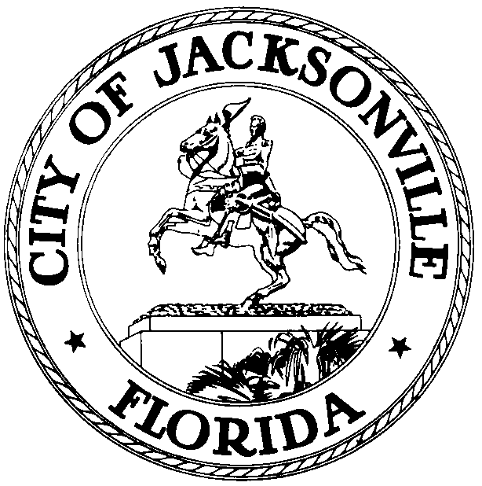

OFFICE OF THE CITY COUNCIL

KEVIN E. HYDE  COUNCIL MEMBER  AT-LARGE, GROUP FOUR  OFFICE (904) 630-1398  FAX (904) 630-2906 |  | SUITE 425, CITY HALL  117 WEST DUVAL STREET  JACKSONVILLE, FLORIDA 32202  E-MAIL: KHYDE@coj.net

December 9, 2009
12:00 P.M.
A M E N D E D N O T I C E

M E M O R A N D U M

TO: The Honorable William Bishop
The Honorable E. Denise Lee
Special Committee Members

FROM: The Honorable Kevin Hyde, Chair
Courthouse Oversight Special Committee

SUBJECT: Amended Location, Notice of Courthouse Oversight Special Committee Meeting December 14, 2009
________________________________________________________________________

As Chair of the above referenced Committee, I am hereby scheduling a meeting on Monday, December 14, 2009 at 4:00 P.M. in the Council Chamber, 1st Floor of City Hall, 117 W. Duval Street, to review the issue of undocumented construction workers.

All interested parties are invited to attend. Please mark your calendars accordingly.

Please contact Philip Zamarron, Legislative Assistant, at (904) 630-1404 for additional information or correspondence.

KH/prz

xc: Council Members/Staff
Cheryl L. Brown, Director/Council Secretary
Courthouse Oversight Committee Aide, Legislative Services Division
Dana Farris, Chief – Legislative Services Division
Carol Owens, Assistant Chief – Legislative Services Division
Jeff Clements, Chief, Research Division
Kristi Sikes, Chief, Administrative Services Division
CITYC@COJ.NET
Posted Notice Board – 1st Floor City Hall
Electronic Notice Kiosk – 1st Floor City Hall
Public Notice System – City Council Web Page
Media Box
File Copy

