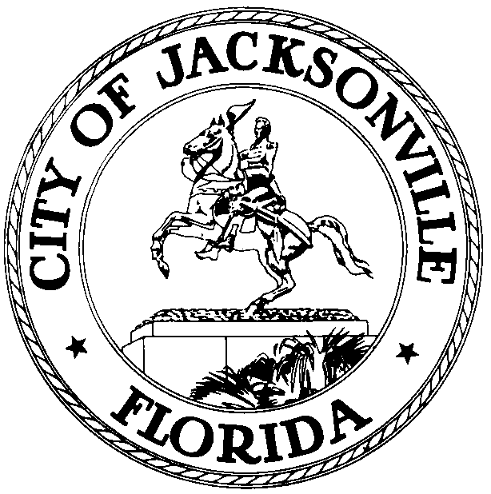

OFFICE OF THE CITY COUNCIL

KEVIN E. HYDE  COUNCIL MEMBER  AT-LARGE, GROUP FOUR  OFFICE (904) 630-1398  FAX (904) 630-2906 |  | SUITE 425, CITY HALL  117 WEST DUVAL STREET  JACKSONVILLE, FLORIDA 32202  E-MAIL: KHYDE@coj.net

October 22, 2009
11 a.m.

NOTICE

Notice is hereby given that Council Member Kevin Hyde will meet with Council Member Jack Webb at 2 p.m. on Wednesday, October 28, 2009 in Conference Room A, Fourth Floor, City Hall, 117 West Duval Street, Jacksonville, FL 32202. The purpose of the meeting is to discuss the city budget, 2009-701 and funding for Jacksonville Area Legal Aid.

2009-701 | ORD-MC Estab a Tentative Budget Process Initiated by May 1st & Concluded by June 30th each Yr; Amend Subpart A (Budgets & Budget Ords; Millage Levy) of Chapt 106 (Budget) by Enacting new Sec 106.200 (Tentative Gen Govt Budget) to Estab said Process; Amend Sec 106.201 (Time of Submission) to change its Title to "Final Annual Budget; Time of Submission" & to Reflect it Addresses the Final Annual Budget. (Rohan) (C/M Webb & Crescimbeni) Public Hearing Pursuant to Chapt 166, F.S. & CR 3.601 - 9/8/09, 9/22/09

All interested persons are invited to attend.

Please contact Alison Miller, ECA, Office of Council Member Kevin Hyde, Council Member At-Large, Group 4, at (904) 630-1398 for additional information.

KEH/aem

cc: Council Members and Staff
Cheryl L Brown, Director and Council Secretary
Dana Farris, Chief of Legislative Services
Carol Owens, Assistant Chief of Legislative Services
Jeff Clements, Chief of Research
CITYC@COJ.NET
Office of General Counsel
Posted Notice Board – 1st Floor City Hall
Electronic Notice Kiosk – 1st Floor City Hall
Public Notice System – City Council Web Page
Media Box
File Copy

