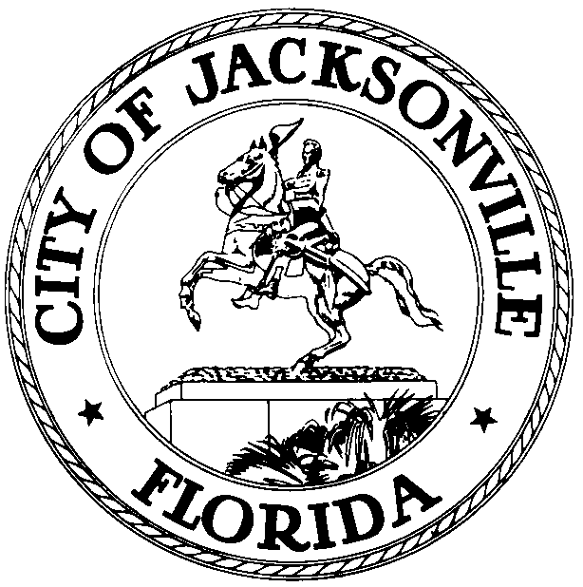

OFFICE OF THE CITY COUNCIL
OFFICE OF THE CITY COUNCIL

RICHARD CLARK 117 WEST DUVAL STREET, SUITE 425
2009 – 2010 PRESIDENT 4TH FLOOR, CITY HALL
OFFICE (904) 630-1386 JACKSONVILLE, FLORIDA 32202
FAX (904) 630-2906
E-MAIL: RCLAEK@COJ..NET
September 16, 2009
(4:00 p.m.)

NOTICE

M E M O R A N D U M

TO: Council Members
Council Staff

FR: The Honorable Richard Clark, President
Jacksonville City Council

RE: Installation - District 13 Council Member
_________________________________________________________________

Notice is hereby given that the Jacksonville City Council will hold the 2009 Installation Ceremony for the Elected Council Representative for Council District 13 on Thursday, September 17, 2009, 4:30 p.m. Council Chambers – City Hall St. James Bldg., 1st Floor City Hall – 117 West Duval Street, Jacksonville, Florida. The ceremony is held to install the Honorable John Meserve as a member of the Jacksonville City Council.

All interested parties are invited to attend.

Please contact Cheryl L Brown, Director, Jacksonville City Council at (904) 630-1377 for additional information or correspondence.

RC/CLB/clb

xc: Cheryl L. Brown, Director/Council Secretary
Dana Farris, Chief – Legislative Services Division
Carol Owens, Assistant Chief – Legislative Services Division
Jeff Clements, Chief, Research Division
Kristi Sikes, Chief, Administrative Services Division
Kirk Sherman, Council Auditor
Mayor’s Office
Office of the General Counsel
CITYC@COJ.NET
Electronic Notice Kiosk – 1st Floor City Hall
Public Notice System – City Council Web Page
Media Box
File Copy

