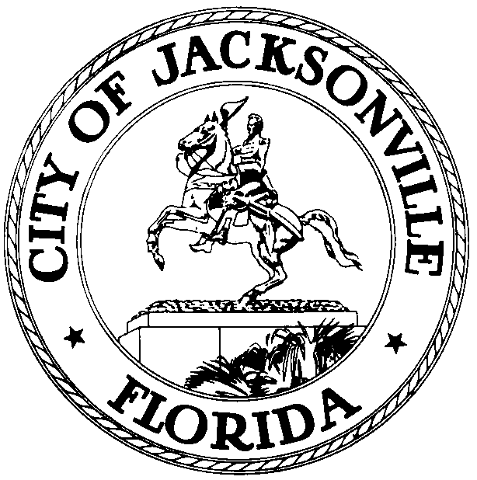

OFFICE OF THE CITY COUNCIL

DANIEL DAVIS 117 WEST DUVAL STREET, SUITE 425
2007 – 2008 PAST PRESIDENT 4TH FLOOR, CITY HALL
OFFICE (904) 630-1380 JACKSONVILLE, FLORIDA 32202
FAX (904) 630-2906
E-MAIL: DDAVIS @COJ..NET

August 24, 2009
(9:00 a.m.)

CANCELLATION NOTICE

Notice of cancellation is hereby given that the Seaport and Airport Special Committee will not meet on Tuesday, August 25, 2009, at 4:00 pm in Conference Room A, 4th Floor, City Hall, St. James Building. The Special Committee will meet at its next regularly scheduled meeting on Tuesday, September 8, 2009, at 4:00 p.m. in Conference Room A, located at 117 West Duval Street, Suite 425, 4th Floor, City Hall St. James Building.

Please contact Merriane Lahmeur or Jessica Stephens, Legislative Assistants, at (904) 630-1404 for additional information or correspondence about this cancellation.

DD/mgl

xc: Council Members/Staff
Honorable Bill Bishop- Liaison - JAA
Cheryl L. Brown, Director/Council Secretary
Merriane Lahmeur- Legislative Assistant II
Dana Farris, Chief – Legislative Services Division
Carol Owens, Assistant Chief – Legislative Services Division
Jeff Clements, Chief, Research Division
Kristi Sikes, Chief, Administrative Services Division
Ron Barton, JEDC
Jessica Deal, Chamber of Commerce Government Affairs
Eric Green, JPA
Rick Ferrin, Executive Director- JPA
John Clark, Executive Director -JAA
Office of the General Counsel
CITYC@COJ.NET
Electronic Notice Kiosk – 1st Floor City Hall
Public Notice System – City Council Web Page
Media Box
File Copy

