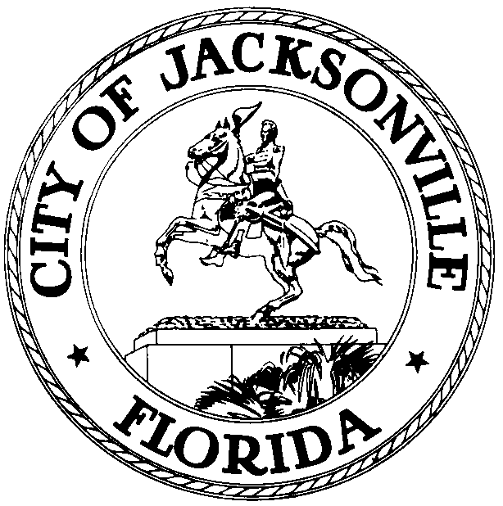

Jacksonville Waterways Commission
Reggie Brown, Chair

Jacksonville Waterways Commission Minutes
August 13, 2009
9:00 AM

Lynwood Roberts Room
1st Floor, City Hall
117 W. Duval Street

The monthly meeting of the Jacksonville Waterways Commission was called to order at 9:03 a.m., Thursday, August 13, 2009, in the Lynwood Roberts Room, by the Chair, Council Member Reggie Brown.

Attendance: Council Members Brown and Jones; Commissioners Grandin, Grey, Hartley, Nichols, Fleming, Busey, Thompson ; Council Member Crescimbini, Commissioners Burnett and Fleming excused; Marilyn Allen, Legislative Assistant; Kristina Nelson, Office of General Counsel; Dr. Quinton White, Dr. Gerard Pinto, Jacksonville University, Capt. Jim Suber, Waterways Coordinator; Susan Stewart, Duval Legislative Delegation; John Jackson, City Council Research Division.

The minutes for the June 11, 2009 meeting of the Commission were approved.

The Chair introduced State Representative Lake Ray as the new member of the Duval Legislative Delegation that is joining the Commission, replacing the late Senator Jim King. In his remarks, Representative Ray commented on the significance of the port and a host of maritime issues that benefited Jacksonville and 10 surrounding counties.

Commissioner Susan Grandin provided the Commission with an update on the Waterways Working Group on Recreational and Commercial Working Waterfronts. Shakeeb Shariff and Kristen Reed of the Planning & Development Department were present to comment and field questions on the draft that had been distributed on Future Land Use Element (FLUE) policies regarding recreational and commercial working waterfronts (RCWW). The next meeting of the
working group/subcommittee was scheduled for September 24, 2009.

In the monthly FIND (Florida Inland Navigation District) update, Jody McDaniel, Planning/
Grants, Planning Department, indicated that two of the FY 2008 Grant Applications had been closed out. The two projects that had been completed were the Castaway Island Dredge project and the Sisters Creek Canoe Launch Phase II project. A question was raised regarding the City’s possibly acquiring a boat ramp on the IntraCoastal Waterway. Nate Rezzeau, Chief of Waterfront Management & Programming Division, Recreation & Community Services Department, indicated that there had been a proposal for the site but that the City had not heard from the property owner.

In the monthly St. Johns River Status Report/Water Quality & Manatee, Dr. Quinton White began by mentioning the return of algae bloom and indicated that a health advisory had been issued since the algae releases a toxin. A factor in the return of the algae bloom was the salinity of the river currently being so low. As the salinity of the river increases, the algae will be reduced. The considerable rain that we have had recently depleted the river’s salinity. The current warmth of the river triggers the algae bloom, as well. Dr. White indicated that we will have the algae bloom for a while until the weather cools.

Dr. White announced that the University of North Florida-Jacksonville University River Study report will be released on August 28, 2009 at the City of Jacksonville’s Environmental Summit.

On manatees, Dr. White said that there were a record high number of manatees sighted in 2009, statewide. The number of manatees sighted in Duval County, however, was low. There were a number of manatee fatalities recorded in Duval County attributed to collisions with large vessels. Dr. White indicated that he has been working on this issue with Mike Getchell of the Jacksonville Marine Transportation Exchange and the Florida Fish & Wildlife Commission. A representative of the Fish & Wildlife Commission, Noel Wingers, noted that a manatee had been rescued in February suffering from a cold stress condition and subsequently released in May. Commissioner Nichols inquired where we were regarding the Duval County Manatee Protection Plan. Dr. White responded that we were awaiting the report of the Boat Traffic Study that is due in December.

Commissioner Thompson asked if anyone had ever been actually arrested for killing a manatee.

Dr. Pinto reported on the last aerial flights, Monday, September 10, and Tuesday, September 11. 10 to 11 manatees were sighted in the river, none in the IntraCoastal Waterway. This is the time of the year that we see a decline in manatees as they begin migrating southward.

In New Business, Mr. Bert Watson continued his advocacy for the berthing of the USS Adams as a maritime museum project in Jacksonville. He was joined in his presentation by State Representative Lake Ray. A key question that remains is precisely where to moor the vessel. All agree that it has to be a site that is at no expense to the taxpayers. Mr. Watson continues to advocate for the Shipyards site. He sees no adverse environmental impact at the Shipyards site. We need to ascertain what the Jacksonville Economic Development Commission’s plans are for the Shipyards property.

Mike Getchell, Jacksonville Marine Transportation Exchange, spoke in support of the Shipyards site as a berth for the Adams. He indicated that the concerns raised by United States Coast Guard regarding mooring the vessel within a half mile of any bridge and the concerns raised by the Jacksonville Marine Transportation Exchange, namely, that the Acosta Bridge location would possibly affect river currents in the federal channel on the Northbank, are now alleviated. Mr. Getchell indicated that the Shipyards site was a much better choice for location from a navigational safety perspective.

Mr. Wayne Misener of the Adams Class Veterans Association and the Jacksonville Historical Naval Ship Association and Captain John E. O’Neil, Jr. (USN Ret) also spoke in favor of berthing the USS Adams in Jacksonville as a maritime museum project.

In Public Comments, Mr. John Nooney advocated for more public access to our waterways, particularly in Jacksonville neighborhoods.

There being no further business, the meeting was adjourned at 10:08 a.m.

The next scheduled meeting of the Jacksonville Waterways Commission is September 10, 2009. The meeting will he held in the City Council Chambers.

John J. Jackson, Council Research Division, (904) 630-1729

