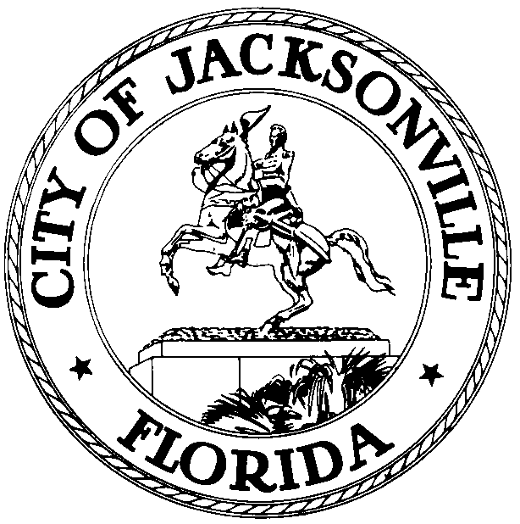

OFFICE OF THE CITY COUNCIL

RICHARD CLARK  COUNCIL PRESIDENT  DISTRICT 3  OFFICE (904) 630-1386  FAX (904) 630-2906 |  | SUITE 425, CITY HALL  117 WEST DUVAL STREET  JACKSONVILLE, FLORIDA 32202  E-MAIL: RCLARK@coj.net

July 16, 2009
(3:00 PM)

Meeting Notice

Notice is hereby given that Council President Richard Clark will meet with Council Vice President Jack Webb on, Monday, July 20, 2009, at 4:15 PM in Conference Room B, located at 117 West Duval Street, Suite 425, City Hall St. James Building. The meeting is to discuss the “Timeline for Millage Notification”.

All interested persons are invited to attend.

Please contact Sonia Johnson, Executive Council Assistant, at (904) 630-1031 for additional information or correspondence.

RAC/sj

CC: Council Members/Staff
Cheryl Brown, Director/Council Secretary
Jeff Clements, Chief, Research Division
Dana Farris, Chief, legislative Services Division
Carol Owens, Assistant Chief of Legislative Services
Kristi Sikes, Chief, Administrative Services Division
CityC@coj.net
Media Box

