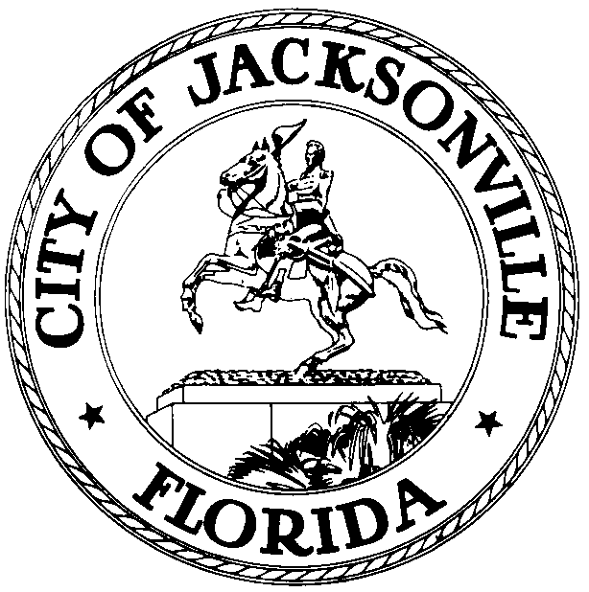

OFFICE OF THE CITY COUNCIL

RICHARD CLARK 117 WEST DUVAL STREET, SUITE 425
PRESIDENT - ELECT 4TH FLOOR, CITY HALL
OFFICE (904) 630-1386 JACKSONVILLE, FLORIDA 32202
FAX (904) 630-2906
E-MAIL: RCLARK@coj.net
N O T I C E

June 26, 2009
(8:00 am)

TO: City Council Members and Staff

FR: Council Member Richard Clark, President -Elect
Jacksonville City Council

RE: SPECIAL MEETING OF THE COUNCIL:
Mayor’s 2009 - 2010 Annual Budget Presentation
__________________________________________________________________________________________

In accordance with Section 106.201. Time of submission:

- The Mayor shall submit the annual budget proposal for the general government to the Council by filing a copy with Legislative Services no later than July 15, unless the Council by resolution fixes another date.”

Notice is hereby given that Council President Elect Richard Clark will meet with Mayor John Peyton and the Members of Jacksonville City Council in a Special Meeting of the Council on Monday, July 13, 2009 at 10:00 a.m., Council Chambers, 1st Floor, City Hall, St. James Building, located at 117 West Duval Street, Jacksonville, Florida. Mayor Peyton will present the 2009-2010 Proposed Annual Budget to the Jacksonville City Council.

Please mark your calendars accordingly. All other interested parties are invited to attend.

If you have any questions, please call the Legislative Services Division at 630-1404.

RC/clb

cc: Council Members/Staff
Cheryl L. Brown, Director/Council Secretary
Dana Farris, Chief – Legislative Services Division
Carol Owens, Assistant Chief – Legislative Services Division
Jeff Clements, Chief, Research Division
Kristi Sikes, Chief, Administrative Services Division
Mayor’s Office
Office of the General Counsel
CITYC@COJ.NET
Electronic Notice Kiosk – 1st Floor City Hall
Public Notice System – City Council Web Page
Media Box
File Copy

